AOSA 2017 *Brassica carinata* referee report prepared by Steve Jones, CFIA Saskatoon Laboratory

Introduction

In 2017 an AOSA referee study was conducted using the newly validated and approved ISTA germination method for *Brassica carinata*. The method became effective for laboratories from 1 January 2018 and is published in the 2018 Edition of the International Methods for Seed Testing (ISTA Rules).

The main aim of the AOSA referee study was to allow N. American laboratories to gain expertise in the new ISTA method. As part of the study ISTA laboratories involve d in the ISTA validation study were also included to see if there was a difference between experienced and less experienced laboratories.

The data collected was analysed by Dr. Jean-Louis Laffont of the ISTA Statistics Committee using a new, easy-to-use analysis tool specific for germination test method validation (see appendix for the detailed analysis). Having an easy to use tool that anyone can use is a very useful addition to aid researchers and accredited laboratories working on optimising germination methods.

Referee design

Six seed lots were tested in 12 laboratories at both temperatures (3 other laboratories participated but only tested samples at one temperature).

The seed lots were from a commercial source in Canada.

Laboratories germinated 400 pure seeds at both a constant 20°C and alternating 20<=>30°C between paper, both folded over paper or rolled towel was permissible.

Results

The data set was analysed including all laboratories (see appendix) and then re-analysed separating out the four ISTA laboratories (detailed analysis is not shown). The repeatability (Sr) and reproducibility (SR) results and the initial ISTA validation study are summarised in Table 1.

**Table 1.** The overall average percentage of normal seedlings (**), repeatability standard- deviation (Sr), dispersion factor (**), reproducibility standard-deviation (SR) with values for laboratory () and lot x laboratory () for germination methods for *Brassica carinata*. Note: repeatability standard-deviations are acceptable if the dispersion factor (*)* is close to 1.

1. Analysis including all 12 laboratories in the AOSA referee

|  |  |  |  |  |  |  |
| --- | --- | --- | --- | --- | --- | --- |
| **Method** |  |  |  |  |  |  |
| 20<=>30°C | 87 | 3.36 | 1.00 | 5.10 | 3.25 | 2.03 |
| 20°C | 88 | 3.32 | 1.00 | 4.59 | 2.37 | 2.11 |

1. Analysis restricted to the four ISTA laboratories in the AOSA referee

|  |  |  |  |  |  |  |
| --- | --- | --- | --- | --- | --- | --- |
| **Method** |  |  |  |  |  |  |
| 20<=>30°C | 87 | 3.85 | 1.13 | 4.89 | 2.59 | 1.54 |
| 20°C | 87 | 3.37 | 0.99 | 4.59 | 1.87 | 2.45 |

1. Analysis for eight laboratories (excluding the four ISTA laboratories) in the AOSA referee

|  |  |  |  |  |  |  |
| --- | --- | --- | --- | --- | --- | --- |
| **Method** |  |  |  |  |  |  |
| 20<=>30°C | 87 | 3.09 | 0.93 | 5.35 | 3.68 | 2.34 |
| 20°C | 88 | 3.30 | 1.01 | 4.65 | 2.56 | 2.06 |

1. Results taken from ISTA validation study (OGM17-07 Method validation Reports on Proposed Changes to the ISTA International Rules for Seed Testing 2018: www.seedtest.org)

|  |  |  |  |  |  |  |
| --- | --- | --- | --- | --- | --- | --- |
| **Method** |  |  |  |  |  |  |
| 20<=>30°C | 92 | 2.92 | 1.06 | 3.58 | 1.09 | 1.77 |
| 20°C | 92 | 2.61 | 0.98 | 3.53 | 1.59 | 1.77 |

Discussion

Reproducibility (SR) was found to be best (lower values) at 20°C in both the ISTA validation study and this referee. The alternating 20<=>30°C values were close to those for 20°C. Repeatability and reproducibility was not as good in the referee study and laboratory variation was higher but the two studies used different seed lots and some different laboratories. The referee study still produced results from laboratories within current acceptable values. Repeatability and reproducibility in the referee study was better for the laboratories involved in the initial study compared to the analysis with all laboratories but there was no reason to restrict the number of laboratories in the AOSA referee study.

Conclusions

The study achieved the objective to provide an opportunity for N. American laboratories to test *Brassica carinata* seed lots using approved ISTA methods.

The next stage in using the new ISTA statistical approach to repeatability and reproducibility is to look at defining thresholds for acceptable repeatability and reproducibility values and the interaction with laboratory and lot numbers. This is an important step forward in reviewing existing and new germination methods to improve uniformity in testing by ensuring all the available germination methods in the ISTA Rules are equally effective.

Acknowledgements

Thanks to Agrisoma Biosciences Inc., Canada for providing the seed lots for the study.

Thanks to Gord Berg, Nicole Wurm, Tanya Neudorf, Maria Cumming, Marge Kowalchuk, Marlene Driedger and Steve Jones at the CFIA Saskatoon Laboratory for planning the study, preparing the samples, as well as testing initial samples and samples in both the ISTA validation study and this referee study.

Thanks to the colleagues and staff from the laboratories who submitted results:

Ag Seed Lab, Canada; BioVision (SGS) Seed Lab, Canada; Kent Agri Laboratory Ltd., Canada; Emily Morrison, Indiana State Seed Lab; Patricia Jones, Florida Department of Agriculture and Consumer Services; David M. Johnston, Louisiana Department of Agriculture and Forestry Seed Lab; Sharon Davidson, Agri Seed Testing; Linda Barbosa, Sakota Seed America Inc.; Liza Hipolito, Incotec USA; Laura Carlson, SoDak Labs Inc; Nicolette Rusch, Eurofins BioDiagnostics Inc;

And the following ISTA accredited laboratories for participating in both the ISTA validation study and this referee study:

CFIA Saskatoon Laboratory, Canada; CREA-SCS Sede di Tavazzano-Laboratorio, Italy; GEVES-SNES, Station Nationale d'Essais de Semences, France; and 20/20 Seed Lab Inc, Nisku, Canada; co-ordinated at the laboratories by Steve Jones, Rita Zecchinelli, Sylvie Ducournau and Carey Matthiessen respectively.

Special thanks also to Jean-Louis Laffont for his analysis and interpretation of the ISTA and AOSA data.

Appendix:

Statistical analysis of the *Brassica carinata* AOSA Comparative Study using the new ISTA germination validation methodology

Prepared by Jean-Louis Laffont – Chair of the ISTA Statistics Committee

**1. Data exploration with side-by-side boxplots**

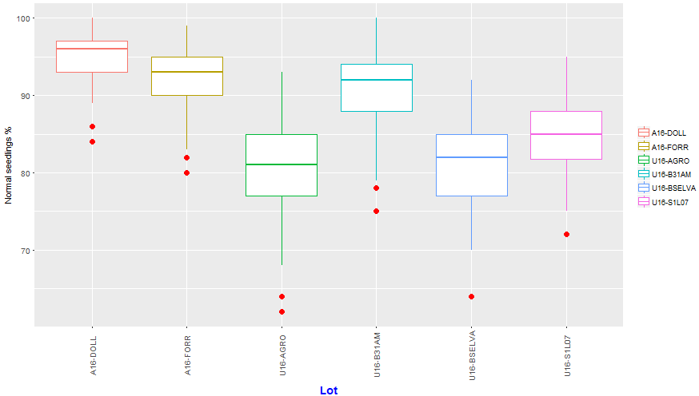

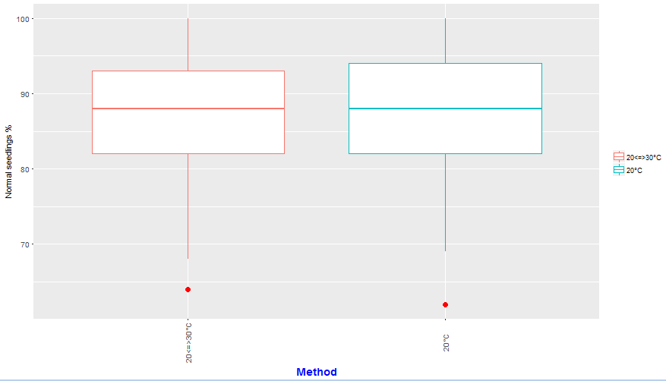

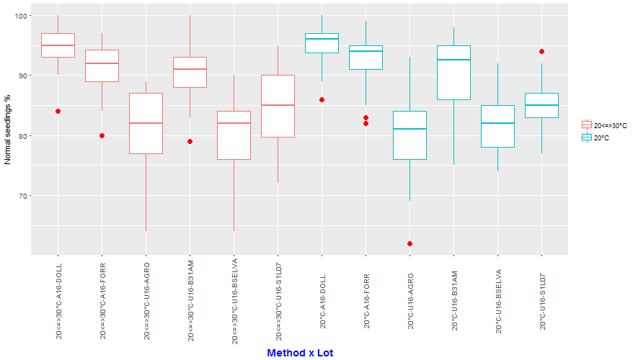

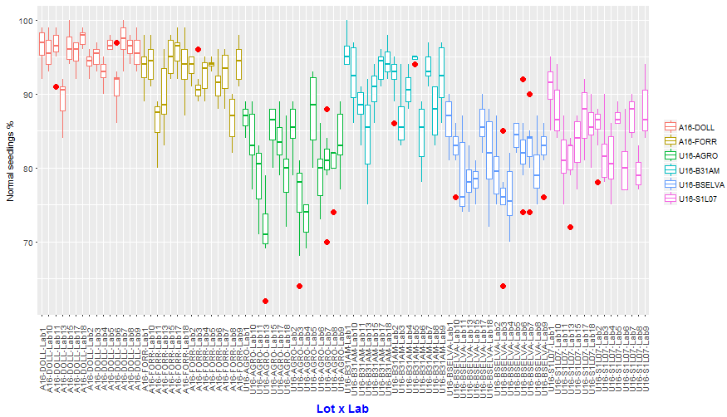

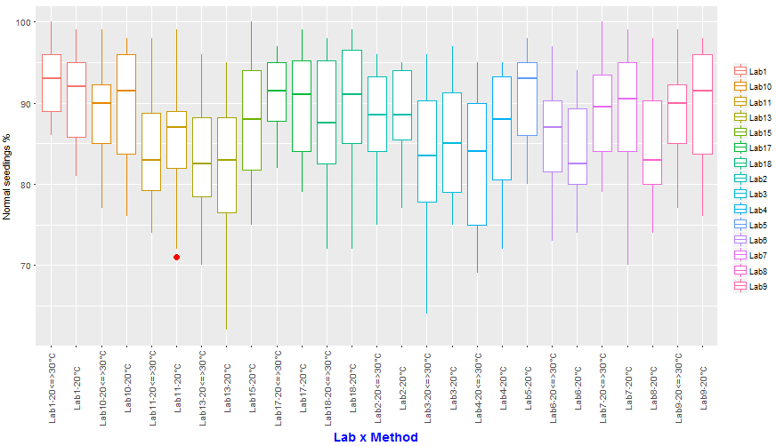

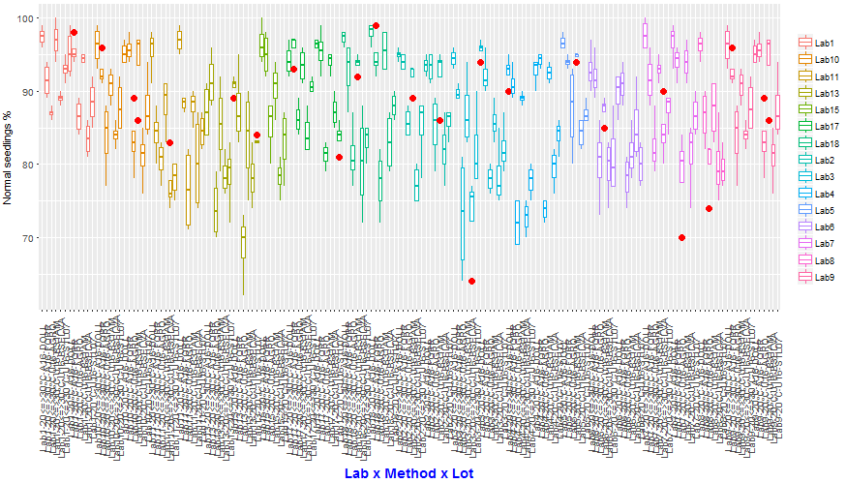

**2. Data checking**

Data checking has been performed according to ISTA rules by computing tolerances for germination test replicates.

Three results are out of tolerance, all for 20°C method:

|  |  |  |  |  |  |  |  |  |
| --- | --- | --- | --- | --- | --- | --- | --- | --- |
| **Method** | **Lot** | **Lab** | **Mean** | **# Reps** | **# seeds/rep** | **Range** | **Tol** | **Out of Tol** |
| 20°C | U16-B31AM | Lab10 | 94 | 4 | 100 | 11 | 10 | OUT |
| 20°C | U16-B31AM | Lab13 | 84 | 4 | 100 | 15 | 14 | OUT |
| 20°C | U16-B31AM | Lab9 | 94 | 4 | 100 | 11 | 10 | OUT |

**3. Repeatability/Reproducibility**

Results:

|  |  |  |  |  |  |  |
| --- | --- | --- | --- | --- | --- | --- |
| **Method** |  |  |  |  |  |  |
| 20<=>30°C | 87 | 3.36 | 1 | 5.10 | 3.25 | 2.03 |
| 20°C | 88 | 3.32 | 1 | 4.59 | 2.37 | 2.11 |

**4. Mixed model for comparing Method and Lot means**

A mixed model was fitted. The Least Squares Means are displayed in the following bar plots with error bars added corresponding to their standard errors:

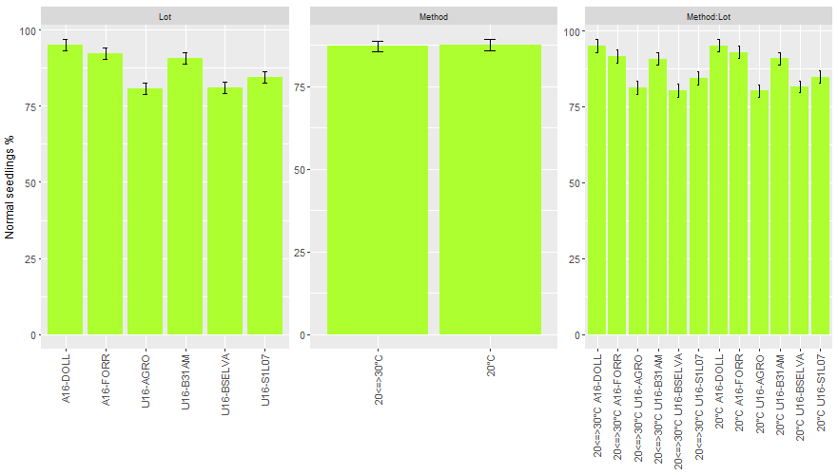

The differences of Least Squares Means table with p-values, standard-errors and 95% confidence intervals are displayed in the following bar plots:

