Rule Proposal #14
1. PURPOSE OF PROPOSAL:
The purpose of this proposal is to improve seedling drawing 2c in POACEAE GRASS FAMILY III - Corn section in AOSA Rules Volume 4. In the current drawing, the coleoptile is not properly depicted and has raised questions from analysts. The description and evaluation of drawing 2c we not changed.

2. PRESENT RULE:
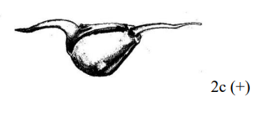
2c. Shoot and root the length of the kernel.

3. PROPOSED RULE:
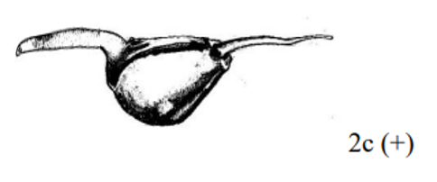

2c. Shoot and root the length of the kernel.

4. HARMONIZATION AND IMPACT STATEMENT: (ISTA/FSA/Canadian Methods & Procedures)
N/A

5. SUPPORTING EVIDENCE:
With the current drawing in AOSA Rules Volume 4, the coleoptile is not very well depicted. This issue has brought questions and concerns from AOSA and SCST analysts to the Co-Chairs of the Germination and Dormancy Subcommittee. To assist with addressing these concerns, the coleoptile has been amended to better depict an appropriate coleoptile for this type of seedling.

6. SUBMITTED BY:
David M. Johnston – RST/CSA Germination and Purity
Program Coordinator Seed Programs
Louisiana Dept. of Agriculture and Forestry
5825 Florida Blvd. – Suite 3004
Baton Rouge, LA 70806
Phone: (225) 952-8059
Email: djohnston@ldaf.state.la.us

Riad Baalbaki, PhD – CSA Germination
Senior Seed Botanist
California Department of Food & Agriculture
Plant Pest Diagnostics Branch
3294 Meadowview Road
Sacramento, CA 95832-1448
Phone: (916) 262-3292
Email: riad.baalbaki@cdfa.ca.gov

7. DATE SUBMITTED:
August 8, 2022

