Rule Proposal #15

1. PURPOSE OF PROPOSAL:
The primary purpose of this proposal is to revise AOSA Rules Volume 4 ASTERACEAE, SUNFLOWER FAMILY I – Lettuce Fig. 3 ‘Physiological necrosis of lettuce cotyledons’ drawings, so that they reflect the recent changes of evaluation criteria described in AOSA Rules Volume 4 under Part I SECTION 3 section 3.5.10 (see excerpt below), and to add additional drawings for necrosis evaluation clarification.
“3.5.10 Decay at the point of attachment of the cotyledons and terminal bud decay. Seedlings exhibiting decay at the point of attachment of the cotyledons to the seedling and/or decay (that was not caused by test conditions) in and around the terminal bud, causes the seedling to be classified as abnormal. The 50% Rule (see section 3.5.8) does not apply when either of these conditions is present.”
Also, the recommendation to use magnification and light to evaluate seedlings exhibiting necrosis to assist with more precise necrosis evaluations has been proposed.

2. PRESENT RULE:
…

NOTES
…

8. The 50% rule must be followed to classify seedlings with damaged cotyledons (dark areas of discoloration or decay) as either normal or abnormal.

…

Fig. 3 Physiological necrosis of lettuce cotyledons.

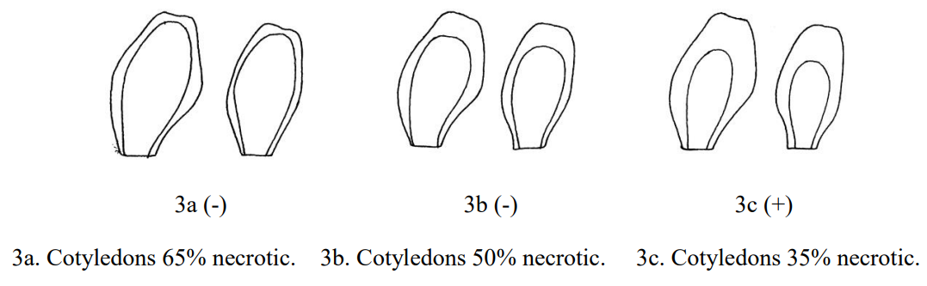

3. PROPOSED RULE:
…

NOTES
…

8. The 50% rule must be followed to classify seedlings with damaged cotyledons (dark areas of discoloration or decay) as either normal or abnormal.

9. Necrosis at point of attachment of a cotyledon causes that cotyledon to be classified as completely defective. A seedling is classified as abnormal if a) both cotyledons show necrosis at point of attachment, or b) one cotyledon shows necrosis at point of attachment and more than 50% of total cotyledonary tissue is defective.

10. The use of light and moderate magnification (e.g., 2X, 3X) are highly recommended to make the evaluation of seedlings exhibiting necrosis less difficult and more accurate.

…

Fig. 3 Physiological necrosis of lettuce cotyledons.

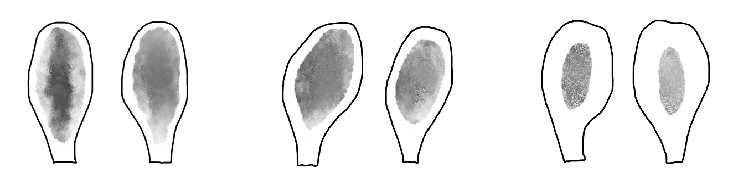

3a (-)
3c (+)
3b (+)

3c. Cotyledons ≈20% necrotic
3b. Cotyledons ≈48% necrotic
3a. Cotyledons ≈60% necrotic

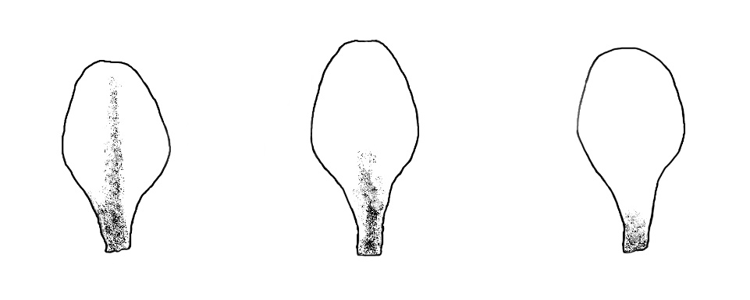

3f (-)
3e (-)
3d (-)
3d-f Necrosis at point of cotyledon attachment

4. HARMONIZATION AND IMPACT STATEMENT: (ISTA/FSA/Canadian Methods & Procedures)

This proposal validates the previous change relating to decay at the point of attachment, which harmonized AOSA Rules evaluation criteria with those in the ISTA Rules. The proposed change will improve uniformity and consistency of evaluations among analysts by using drawings to assist analysts with correctly evaluating lettuce cotyledons based on the degree and pattern of necrosis, which was had not been previously illustrated.

5. SUPPORTING EVIDENCE:

The current Fig. 3 drawings were not updated when evaluation criteria specific to point of attachment of cotyledons to hypocotyls was updated. The current Fig. 3 drawings do not show complete lettuce cotyledons, especially the point of attachment to the hypocotyl, a critical evaluation area.

Therefore, the current figures do not illustrate how patterns of necrosis, particularly when the necrosis is at the point of attachment, should be evaluated. Revised Fig. 3 a-c drawings basically illustrate the same concept as those used in the current figure but add the ‘missing’ part of each cotyledon. New additional Fig. 3 d-f, as well as Note 9, illustrate proper evaluation of necrosis at the point of attachment, even when less than 50% of the cotyledon is affected. These changes are necessary to align Fig. 3 with the revised evaluation criteria previously adopted.

6. SUBMITTED BY:

David M. Johnston – RST/CSA Germination and Purity
Program Coordinator Seed Programs
Louisiana Dept. of Agriculture and Forestry
5825 Florida Blvd. – Suite 3004
Baton Rouge, LA 70806
Phone: (225) 952-8059
Email: djohnston@ldaf.state.la.us

Riad Baalbaki, PhD – CSA Germination
Senior Seed Botanist
California Department of Food & Agriculture
Plant Pest Diagnostics Branch
3294 Meadowview Road
Sacramento, CA 95832-1448
Phone: (916) 262-3292
Email: riad.baalbaki@cdfa.ca.gov

7. DATE SUBMITTED:
October 5, 2022

