Rule Proposal #16

1. PURPOSE OF PROPOSAL:
Improve uniformity of evaluating cotyledons of lettuce seedlings with various degrees and patterns of necrotic tissue damage. Color pictorial examples, with a range of symptoms, are proposed as supplementary material to the ‘ASTERACEAE, SUNFLOWER FAMILY I – Lettuce’ section of Vol. 4 of the AOSA Rules. Black and white seedling drawings depicting necrosis are inadequate due to their lack of coloration and detail. No changes in evaluation rules are proposed.

2. PRESENT RULE:
None. Currently there are no photos in AOSA Rules Vol. 4

3. PROPOSED RULE:
Proposed supplementary material for addition to the ‘ASTERACEAE, SUNFLOWER FAMILY I – Lettuce’ section

Supplemental Evaluation Guide
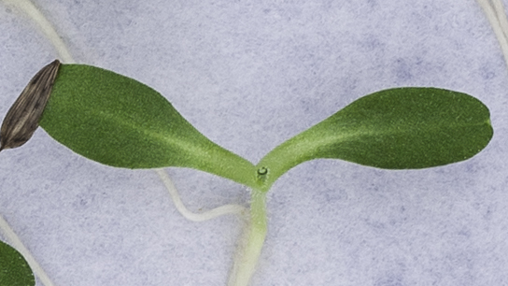 | Figure 1  Normal  Healthy cotyledons. Lighter coloration is normal for lettuce at point of attachment to hypocotyl. Intact epicotyl.  Figure 2
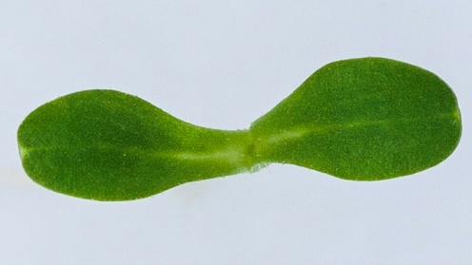 | Normal  Figure 2  Lighter areas (sometimes tissue appears transparent) at the point of attachment to hypocotyl and cotyledon tips are normal for lettuce.
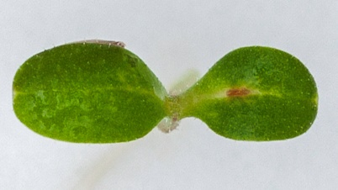 | Normal  Figure 3  Minor necrosis on one cotyledon. Apparent blotchiness on surface is outer epidermal cells of cotyledons.  Figure 4
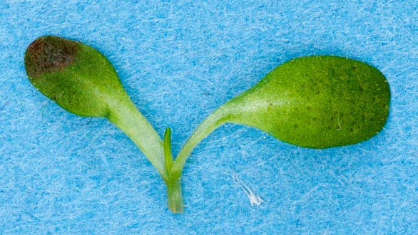 | Normal  Necrosis or decay affects less than 50% of cotyledon tissue. No necrosis at point of attachment to hypocotyl. Healthy epicotyl.
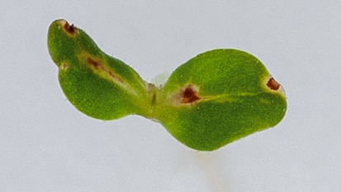 | Figure 5  Normal  Physical necrosis affecting less than 50% of cotyledon tissue; no necrosis at point of attachment to hypocotyl.
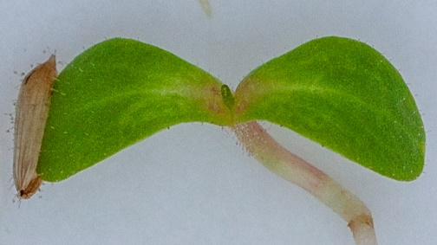 | Figure 6  Abnormal  Necrosis at the point of cotyledon attachment to the hypocotyl.
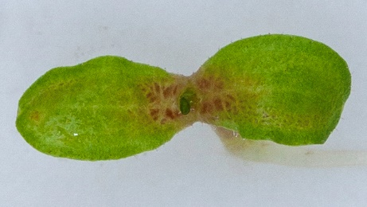 | Figure 7  Abnormal  Severe necrosis at the point of cotyledon attachment to the hypocotyl as well as other pre-necrotic (light green or brown) cotyledonary tissue.
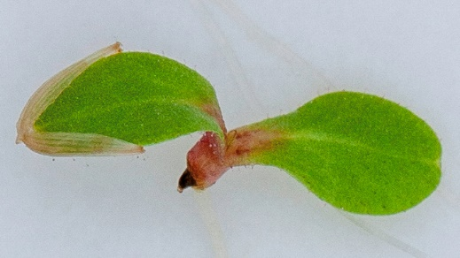 | Abnormal  Figure 8  Necrosis or decay at point of attachment, extending into the hypocotyl and the epicotyl.
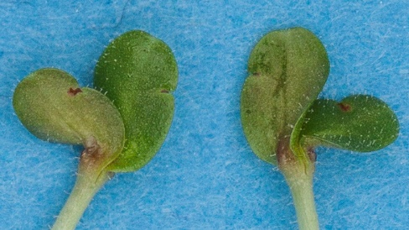 | Abnormal  Figure 9  Necrosis at the point of cotyledon attachment to the hypocotyl. Same seedling is depicted from two angles.
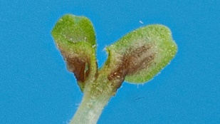 | Figure 10  Abnormal  Necrosis at the point of cotyledon attachment to the hypocotyl and extending to the rest of the cotyledons.
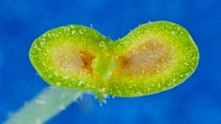 | Figure 11  Abnormal  Necrosis affecting more than 50% of cotyledonary tissue. Light-green tissue surrounding dark necrotic area is an example of early stages of necrosis.
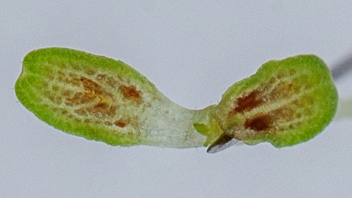 | Figure 12  Abnormal  Necrosis and pe-necrosis affecting most cotyledonary tissue. ‘Transparent’ tissue of the cotyledon-hypocotyl juncture is normal for lettuce.
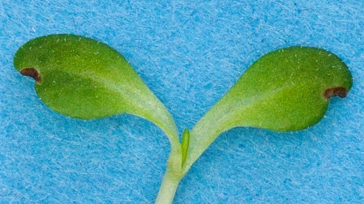 | Figure 13  Normal  Physical necrosis, usually due to insect or mechanical damage. Epicotyl is healthy. ‘Transparent’ tissue at the hypocotyl juncture is normal.
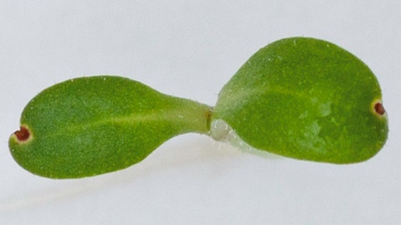 | Figure 14  Normal  Example of physical rather than physiological necrosis due to insect or mechanical damage, affecting less than 50% of cotyledon tissue.
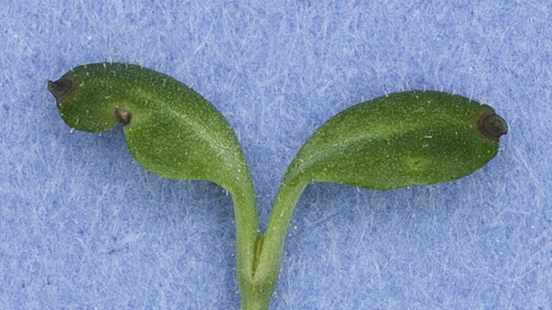 | Figure 15  Normal  Another example of physical necrosis due to insect or mechanical damage, affecting less than 50% of cotyledon tissue.
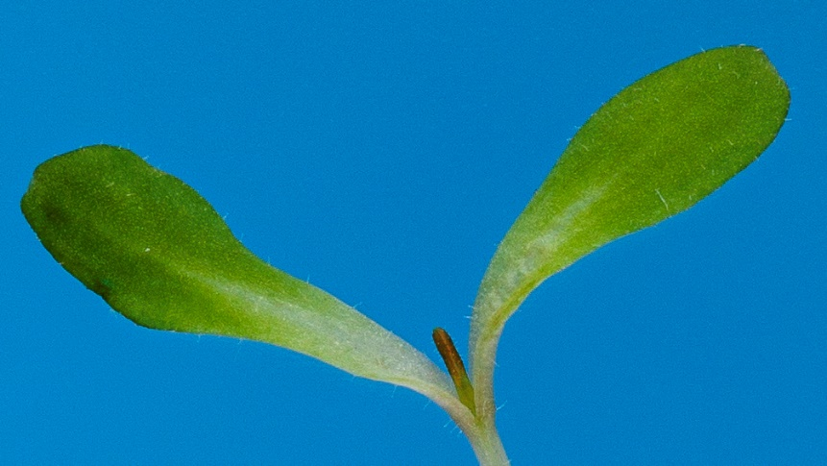 | Figure 16  Abnormal  Decayed epicotyl. Without the aid of magnification, epicotyl deterioration might not be apparent. Healthy cotyledons with normal semi-transparent tissue at the hypocotyl juncture-normal for lettuce.

4. HARMONIZATION AND IMPACT STATEMENT:
No changes in evaluation rules or criteria are proposed, so this proposal has no impact on harmonization. However, the pictorial illustrations enhance uniformity among AOSA, ISTA, and Canadian M&P by demonstrating similarities in evaluating necrosis at the cotyledon-hypocotyl juncture.

5. SUPPORTING EVIDENCE:
Authors reviewed three lettuce referee results which, to our knowledge, were the only lettuce referees in the past 10 years (attached). Review results indicated that necrosis evaluation remains a major area of concern and lack of uniformity. Some referee responses specific to necrosis sometimes diverged by more than 40% among respondents. The reviewed referees were:
- 2013 Virtual Lettuce Referee; Seedling Evaluation Handbook Committee (henceforth referred to as VLR)
- 2016 Southwest Region Referee (henceforth referred to as SWRR)
- 2022 CFIA Referee Study on Lettuce Seedling Evaluation (henceforth referred to as CFIA).
Our review identified four common themes:
- General agreement when evaluating obvious cases of either intact or severely defective seedlings. Examples include VLR images 2, 4 and 5; and CFIA images 2, 6, 7 and 8.
- A moderate to high degree on variation among analysts when evaluating necrosis at the point of attachment of cotyledons to the hypocotyl. Examples include VLR images 1 and 25; SWRR images 2, 5 and 9; and CFIA images 9, 12 and 13. In the case of CFIA images 9 and 12, it was apparent that many AOSA analysts do not consider necrosis at point of attachment as an abnormality if less than 50% of the cotyledonary tissue is defective,
- Difficulty in sometimes distinguishing pre-necrotic tissue, usually apparent around darker necrotic areas, from light (low chlorophyl) coloration of normal tissue, which in the case of lettuce is highly dependent on test conditions. Examples include VLR images 18 and 28; SWRR images 2, 4, 7 and 10; and CFIA images 1, 5 11 and 14.
- It was not possible to draw any reliable conclusions regarding pigmentation evaluations, but it seems likely that pigmentation differences influenced cotyledon evaluations. In most cases, this tissue appears lighter in color or transparent (lacks pigmentation), which is a normal condition for lettuce and is light- and variety-dependent. Based on some referee results, this lack or reduced pigmentation could have been regarded as a defect. Examples include VLR images 3, 15, 18 and 26.
The proposed supplementary material provides examples and descriptions of cotyledon evaluations to address and clarify the above issues. No modifications to evaluation criteria are proposed.
NOTE: THIS PROPOSAL IS CONTINGENT ON PROPOSAL #15 PASSING
6. SUBMITTED BY:
Riad Baalbaki, CSA Germination - Dormancy and Germination Subcommittee Co-Chair
Senior Seed Botanist
California Department of Food & Agriculture
Plant Pest Diagnostics Branch
Email: riad.baalbaki@cdfa.ca.gov

David M. Johnston, CSA/RST - Dormancy and Germination Subcommittee Co-Chair
Program Coordinator Seed Programs
Louisiana Dept. of Agriculture and Forestry
Email: djohnston@ldaf.state.la.us

7. DATE SUBMITTED: October 14, 2022

