RULES CHANGE PROPOSAL - #2

- PURPOSE: To add Salvia hispanica germination methods to table 6A.

- PRESENT RULE:
None

- PROPOSED RULE:
Table 6A. Methods of testing for laboratory germination.
Kind of Seed | Substrata ª | Tempera-ture  (°C) | First  count  (days) | Final  count  (days) | Specific requirements and notes | Fresh and dormant seed
Salvia hispanica  chia | P | 20;  20-30 | 7 | 14

- HARMONIZATION AND IMPACT STATEMENT: ISTA Rules for Seed Testing has Salvia hispanica methods in the purity and germination chapters. Canada Methods and Procedures do not mention Salvia hispanica and neither does AOSA Rules. Salvia hispanica, originally from southern North America and northern South America, is expanding outward to other countries. There has been renewed interest in chia as an excellent source of ω3 fatty acids and dietary fiber for healthy diets. 1 Its demand is steadily increasing in Australia and United States, as a health food.

- SUPPORTING EVIDENCE:
Germination methods
The Salvia hispanica seeds were compared by germinating the seed at 20<=>30°C and 20°C; plus, use of a prechill and no prechill. A germination cabinet was used in all laboratories except one laboratory utilized a Jacobsen table. For each method and seed lot, 400 seeds were planted on top of paper moistened with water. When prechill was performed, the seed was placed in 5-10°C for 5 days method. The samples were then moved to 20<=>30°C or 20°C for the germination period. The first count was conducted at 7 days, with an additional count performed at 14 days and a final evaluation at 21 days. One laboratory did an initial count at 5 days and one laboratory did an initial count at 6 days with also doing the 7, 14, and 21 day counts. Salvia hispanica seedlings grew so quickly, that the laboratory felt the count needed to be done before 7 days.
The evaluation of the seedlings was made according to seedling type E and seedling group A-2-1-1-1 from the ISTA Handbook on seedling evaluation. In the case of 5% or more fresh seed, the seeds were evaluated as fresh or dead by using Tetrazolium. The common abnormalities found were primary infection of the seedling, primary root missing or defective and cotyledon damage.
Statistical analyses
Statistical analyses were performed using the new R package developed by the ISTA Statistics Committee ‘ISTAgermMV’.
Results and Discussion
Fresh seeds were not found to be present in any of the seed lots. Prechilling the samples did not promote the germination percentage. The results between 20°C and 20<=>30°C were comparable with germination results from 20°C slightly higher than 20<=>30°C. The mean result for TP 20<=>30°C is 94%, TP 20°C is 94%, TP Prechill 20<=>30°C is 90% and TP Prechill 20°C is 92%.
The speed of germination was found to be quick. Most of the Salvia hispanica was germinated in 7 days. The difference between the 14 day and 21 day count is an average of 0.4% across all samples and methods.
Table 1. Germination percent by 7, 14, & 21 days
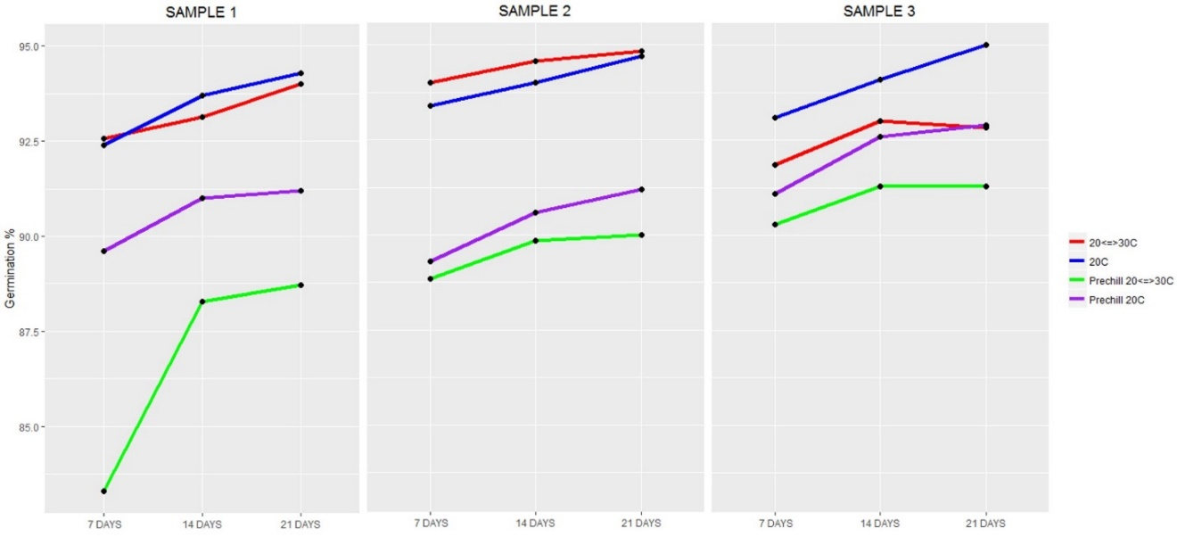
Germination results by seed lot
The average germination of each seed lot across all temperatures was very similar. The range of germination percentage was 85% to 98% overall. Low germinating lots of Salvia hispanica seed were not available.
Germination results by method
The results between methods showed the prechill samples having lower germination than the no prechill samples. However, the range between the prechill and no prechill is small. This shows that dormancy was not an issue with these lots.
Table 3. Average germination results by each method.
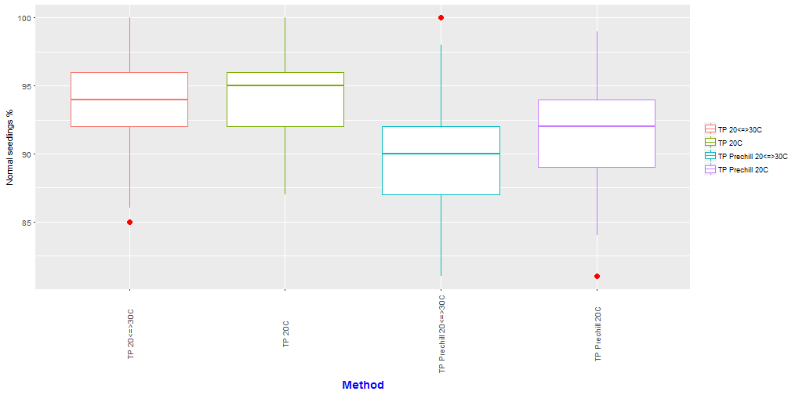
General conclusion
This study shows that Salvia hispanica grown both at 20°C and 20<=>30°C, with Top of Paper and moistened with water, provide adequate growing environments for Salvia hispanica (chia). Testing without a prechill gave higher results compared to testing with a prechill at 5-10°C. The prechill method was significantly different from the no prechill method. The temperature 20°C produced slightly higher and more consistent results than 20<=>30°C. The difference between the 14 day count and the 21 day count is on average 0.4%. With this low increase, a germination duration of 14 days is suggested.
Both temperatures are suitable for germinating Salvia hispanica, however due to the results, a prechilling method is not suggested in the International Rules for Seed Testing. Both temperatures 20°C and 20<=>30°C with the Top of Paper method are recommended and a first count at 5-7 days with final being at 14 days.

References
1. Jamboonsri, W., Phillips, T. D, Geneve, R. L, Cahill, J. P, & Hildebrand, D. F. (2012). Extending the range of an ancient crop, Salvia hispanica L.—a new ω3 source. Genetic resources and crop evolution, 59(2), 171-178. doi: 10.1007/s10722-011-9673-x
2. International Seed Testing Association. 2022. ISTA International Rules for Seed Testing. Bassersdorf, Switzerland.

- SUBMITTED BY:

Sarah Dammen, RST
SGS
1405 32nd Ave
Brookings, SD 57006
Email: sarah.dammen@sgs.com
Phone: 605-692-7611
Fax: 605-692-6657

- Date Submitted:

August 11, 2022

