1. Define Paired Tests?
2. What is Pure Live Seed (PLS)?
   1. If Pure Seed = 99.28%; Germination = 75%, Hard seed = 8%, Dormant seed = 20% then what is the Pure Live Seed (PLS) percentage?
3. Given germination is 95%, found was 86% is the test in tolerance with the following number of seeds
   1. 200 seeds
   2. 400 seeds
4. Where light is prescribed in Table 6A, it should be provided by a cool white fluorescent or LED (Light-Emitting Diode) source. The illuminance for dormant seed should be? (Pick One)
   1. 25-75 ft-c
   2. 50-75 ft-c
   3. 75-125 ft-c
   4. 75-150 ft-c
5. Please answer the following regarding a 20-30°C Light Chamber:
   1. How many hours at 30°C?
   2. How many hours at 20°C?
   3. At what temperature will the Light be on?

IF FALSE PLEASE EXPLAIN WHY?

1. True or False: The pure seed for the germination test shall be taken indiscriminately from a representative portion divided from the bulk in accordance with section 2.2 if the pure seed is estimated to be at least 96 percent?
2. True or False:  You would plant 400 seeds if in a mixture the seed of a kind is given to be 15%?
3. True or False:  In case of equal fractions, the priority for rounding up is abnormal seedlings, dormant seeds, hard seed and dead seeds?
4. Please round the following analysis:
   1. Normal: 63.25
   2. Abnormal: 11.50
   3. Hard: 5.50
   4. Dead: 19.75
5. If the germination results of the first test are 92%, second test 78%, third test 82%, what is the percent germination reported as?
6. Round the following analysis:
   1. Normal: 72.00
   2. Abnormal: 8.50
   3. Hard: 6.50
   4. Dormant: 4.50
   5. Dead: 8.50
7. Round the following analysis:
   1. Normal: 73.25
   2. Abnormal: 7.25
   3. Dormant: 10.25
   4. Dead: 9.25
8. Define “Moisture on the dry side”
9. In the case of species of *Trifolium*, *Medicago* and *Vicia faba*, the temperature should not exceed _________°C
10. True or False: A seedling that has been seriously damaged by bacteria or fungi from any source other than the specific seed shall be regarded as abnormal if it is determined that all essential structures are present? (If false explain)
11. How do epigeal and hypogeal germination differ?
12. Name three factors required for germination to occur?
13. Describe four instances when you would retest a sample as per AOSA Rules for Testing Seeds?
14. Name one advantage and one disadvantage of TZ testing?
15. How does vigor differ from germination?
16. The following formula may be used as a guide in the preparation of sand for germination tests:

***118.29 cc(1 gil) sand  x 20.2 – 8.0 = The number of mls of water added to each***

***It’s weight in grams                                 100 grams air-dried sand.***

If a gill of sand weighs 177.9 grams, how much water would you need to add to 300 grams of air-dried sand?  Please show your work.

1. True or False: If the germination is over 90% one does not have to determine viability of dormant seed?
2. Describe special procedures and alternate methods for germination for the following seeds
   1. Alyceclover-
   2. Rice-
   3. Buffelgrass-
   4. Endive-
   5. Cotton-
3. True or False: When planting single coated seed kind one must plant the seed without removing coating material?
4. What do the following symbols for substrata stand for?
   1. A:
   2. OT:
   3. PT:
   4. RB:
   5. TCS:
5. Name at least 5 seed kinds that can be used to test whether the paper substratum is toxic to developing seedlings?
6. True or False: On the report of analysis you can replace percent germination, dormancy, and or hard seed with Total viability?
7. Name four families of seed that if there are still swollen seeds present or seeds that have just started to germinate, all seeds or seedlings except the above stated shall be removed and the test continued for up to five additional days. Any additional normal seedlings shall be included in determining the percentage of germination?
8. Name five germination promoting chemicals?
9. If an analyst plants timothy in a petri dish and gets 55% germination, then they go to Table 6A and sees that timothy can also be planted on TB, and plants the second test on TB and gets 65% germination.  What do they report as germination percentage on the report of analysis?
10. If given germination is 90% and found germination was 81% is the following two tests within tolerance if…
11. 400 seeds were planted?
12. 200 seeds were planted?
13. **True or False:** For Fabaceae: Cotyledons that are broken apart but held together by the seed coat shall be classified as pure seed. Cotyledons that have separated and are not held together by the seed coat are regarded as inert matter irrespective of whether or not the radicle-plumule axis and/or more than half of the seed coat may be attached?
14. **True or False:** Barley that has a caryopsis larger than one-half the original size is considered Pure Seed?
15. **True or False:** Mustard seed that does not have a seed coat, but is fully intact is considered a Pure Seed?
16. **True or False:** Seeds of Cucurbitaceae and Solanaceae that are not filled are considered Inert Matter?
17. **True or False:** When coated seed units are de-coated for purity analysis on a Kentucky Bluegrass the Uniform Blowing Procedure is to be used?
18. Determine whether a germination retest is necessary based on the following results:

|  |  |  |  |  |  |  |
| --- | --- | --- | --- | --- | --- | --- |
| **Sample** | **Rep 1** | **Rep 2** | **Rep 3** | **Rep 4** | **Average** | **Retest(Y/N)** |
| A | 98 | 95 | 90 | 96 |  |  |
| B | 95 | 78 | 84 | 89 |  |  |
| C | 68 | 75 | 78 | 92 |  |  |
| D | 84 | 75 | 90 | 88 |  |  |
| E | 99 | 98 | 91 | 85 |  |  |

1. What do the following Acronyms stand for:
   1. AASCO-
   2. ASTA-
   3. AOSCA-
   4. FSA-
   5. CFIA-
2. When reporting results of a germination test, how many decimals shall be used?
3. Name three pieces of information that must appear on a report of analysis?
4. Define Tetrazolium test and how it functions?
5. Define Monocotyledon and a Dicotyledon and give 2 examples of each?
6. Name four sources the storage tissue may originate from?
7. Name three major functions of the root system?
8. **True or False**: The Coleoptile is present in most Dicotyledon seeds?
9. Define these structures as are found in **Dicotyledon** seeds:
   1. Hypocotyl-
   2. Cotyledons-
   3. Epicotyl-
   4. The Terminal Bud-
10. Identify the parts in the following cross-section.

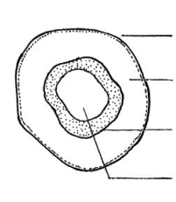

1. Name any 5 causes of Seedling Abnormalites and describe them?
2. **True or False**: Some storage insects eat away the embryo and scutellum and leave the endosperm, in which case the seed will germinate, but will be too weak to continue development?
3. When decay is present in a test, counts should be made at approximately ­__________ day intervals between the first and final counts.
4. Name five practices to minimize the spread of mold?
5. Define Negative geotropism?
6. Deep open cracks extending into the conducting tissue of the hypocotyl or epicotyl are considered to be abnormal, list 2 reasons why
7. List 6 essential structures necessary for the development of a seedling?
8. **True or False**: A healed break in the hypocotyl, of garden bean or lima bean, sometimes referred to as a “knee” is considered to be abnormal?
9. Name four advantages of using sand or soil over artificial substrata?
10. Explain the fifty percent rule as it pertains to cotyledonary tissue?
11. Describe the germination process?
12. Tightly adhering seed coats may be an indication that the_____________ are necrotic or decayed.
13. For the picture below label the pictures normal or abnormal.

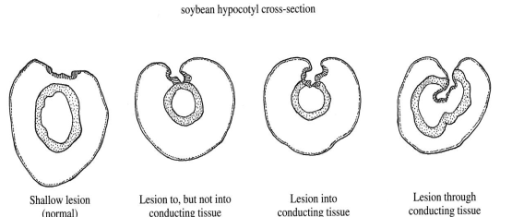

      ________                 ________               ________               _______

1. **True or False:** Seedlings exhibiting decay at the point of attachment of the cotyledons to the seedling and/or decay (**Less than 50%**, and that was not caused by test conditions) in and around the terminal bud, causes the seedling to be classified as normal?
2. Name four reasons for performing a tetrazolium test?
3. Label the parts of the bean seedling:

                               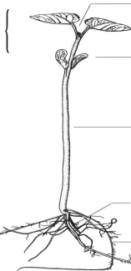

1. Is the following Alfalfa seed Normal, or Abnormal?  If Abnormal explain

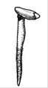

1. **True of False:** When evaluating small grains (wheat, rye, oat..etc) if there is less than two strong seminal roots it is classified as abnormal?
2. In general, what kind of tissue in seed stains when exposed to TZ?
3. (Credit: Iowa State University Seed Lab)

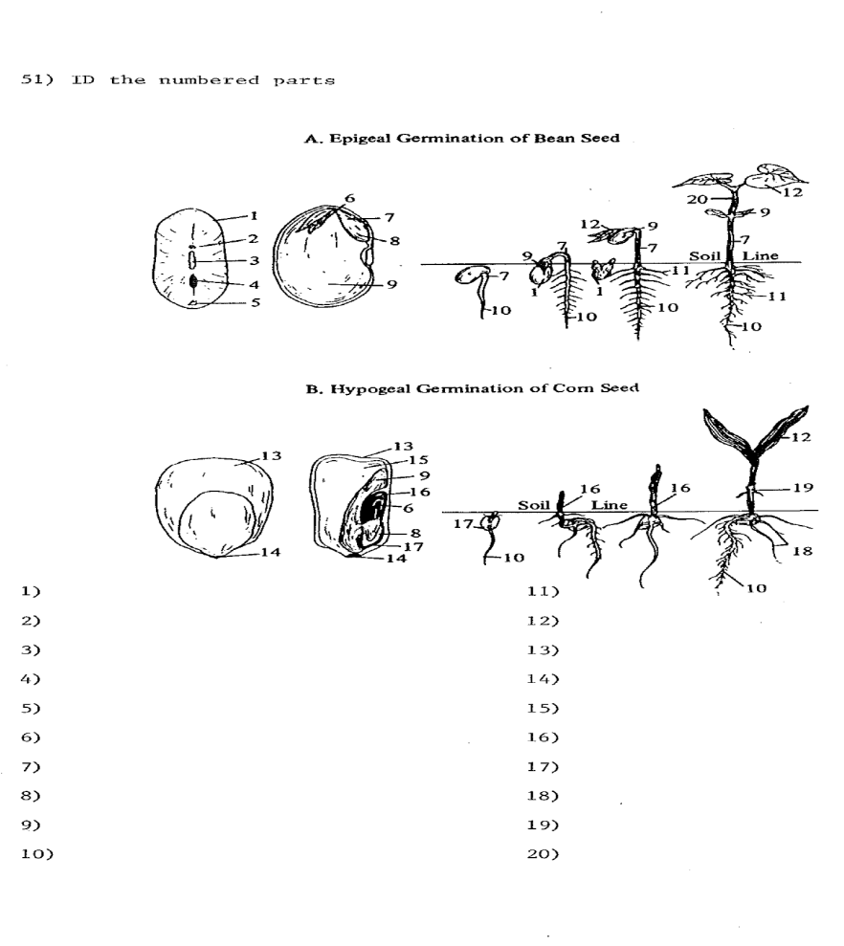

1. Define:
   1. Germination-
   2. Hard Seed-
   3. Dormant Seed-
   4. Prechill-
   5. Paired tests-
   6. Total Viability
2. **MATCH THE FOLLOWING SEEDS TO THEIR SPECIAL PROCEDURES AND ALTERNATE METHODS FOR GERMINATION (SEE PAGES BELOW CHART, A-Q)**

|  |  |
| --- | --- |
| **SEED** | **ANSWER** |
|  |  |
| **1.      Centipedegrass** (*Eremochloa ophiuroides*) |  |
|  |  |
| **2.     Green needlegrass** (*Nassella viridula*). |  |
|  |  |
| **3.      Ryegrass** (*Lolium* spp.) |  |
|  |  |
| **4.     Garden bean** (*Phaseolus vulgaris*) |  |
|  |  |
| **5.      Cotton** (*Gossypium* spp.) |  |
|  |  |
| **6.      Beet, Swiss chard** (*Beta* spp.) |  |
|  |  |
| **7.      Alyceclover** (*Alysicarpus vaginalis*). |  |
|  |  |
| **8.      Rescuegrass** (*Bromus catharticus*). |  |
|  |  |
| **9.      Firecracker penstemon** (*Penstemon eatonii*) |  |
|  |  |
| **10.  Bahiagrass** (*Paspalum notatum*) |  |
|  |  |
| **11.  Penland's beardtongue** (*Penstemon penlandii*). |  |
|  |  |
| **12.  Onion** (*Allium cepa)* |  |
|  |  |
| **13.  Buffelgrass** (*Pennisetum ciliare*)*.* |  |
|  |  |
| **14.  Endive** (*Cichorium endivia*) |  |
|  |  |
| **15.  Rice** (*Oryza sativa*) |  |
|  |  |
| **16.  Crownvetch** (*Securigera varia*). |  |
|  |  |
| **17.  Needle-and-thread** (*Hesperostipa comata*). |  |

1. Swollen seeds: At the conclusion of the 21-day test period carefully pierce the seed coat with a sharp instrument and continue test for five additional days. Alternate method: The swollen seeds may be placed at 20°C for 48 hours and then at 35°C for three additional days.
2. All cultivars except ‘Pensacola’: Remove the enclosing structures (glumes, lemma and palea) from the caryopsis with the aid of a sharp scalpel. If the seed is dormant, scratch the surface of the caryopsis lightly.
3. Before placing seeds on germination substratum, they shall be soaked in water for two hours, using at least 250 ml of water per 100 seeds, then washed in running water and the surface blotted dry. Temperature of the soaking and/or washing water should be no less than 20°C. Samples producing darkened radicles should be retested in soil or by washing in running water for three hours and tested on “Kimpak,” keeping the seed covered with slightly moist blotters. In the case of sugar beet, a 16-hour soaking period in water at 25 °C may be required, followed by rinsing and a two hour drying period at room temperature.
4. Alternate method for dormant seed: Remove the caryopses from the fascicles and place on blotters moistened with potassium nitrate (KNO3; 0.2%), in petri dishes. The seeds from each fascicle should be arranged so they will not be confused with seeds from other fascicles during the test. Prechill at 5 °C for seven days and then germinate at 30 °C in light for 21 additional days. Firm ungerminated seeds remaining at the conclusion of the test period should be scratched lightly and left in test for seven additional days.
5. Samples of cotton seed that do not respond to the usual method should be placed in a closed container with water and shaken until the lint is thoroughly wet. The excess moisture should then be blotted off.
6. For dormant samples add about 1/8-inch of water at the beginning of the test and remove excess water after 24 hours.
7. Wash dormant seed for 48 hours in running water, or soak for 48 hours, changing water and rinsing each morning and night.
8. Flood test: The seed is planted in moist sand. On the seventh day of test add water to a depth of ¼ inch above the sand level and leave the remainder of the test period. Only a final count is made.
9. Fluorescence test: The germination test for fluorescence of ryegrass shall be conducted in light (not to exceed 100-foot candles) with white filter paper as a substratum. The seeds should be spaced so that roots of adjacent seedlings will not come in contact. If there are over 75 percent fluorescent seedlings at the time of the first reading, break the contact of the non-fluorescent seedlings with the paper and reread the fluorescence after at least three days. Distilled or deionized water shall be used to moisten filter paper. Refer to section 5.2 b (2).
10. Use of calcium nitrate: If hypocotyl collar rot is observed on seedlings, the sample involved shall be retested using a calcium nitrate [Ca(NO3)2; 0.3 - 0.6%] solution to moisten the substratum. Refer to section 6.9 j.
11. Two test methods as prescribed in Table 6A shall be used on each sample: For Method 1, acid scarify 400 seeds for 10 minutes in sulfuric acid (H2SO4; 98%).Rinse seeds and dry on blotters for 16 hours. Then place seeds on blotters moistened with gibberellic acid [GA3; 0.055% (500 ppm)] and thiram [0.46% (3000 ppm)] and germinate 14 days. As an alternative to Method 1, conduct a tetrazolium (TZ) test on 400 seeds (see section 8). For Method 2, plant 400 seeds on blotters moistened with potassium nitrate (KNO3; 0.2%) and germinate 14 days. Refer to section 6.7 d for calculation and reporting of results.
12. Two test methods as prescribed in Table 6A shall be used on each sample. For Method 1, submerge 400 seeds in aerated gibberellic acid (GA3; 350 ppm) for 24 hours at room temperature using an aquarium pump. Use enough volume of GA3 solution to completely cover seeds. After treatment, blot excess moisture off seeds and place seeds on water-moistened blotters and germinate in 15-25°C. After 14 days, count normal seedlings; clip either end of remaining ungerminated seeds and continue germination for seven additional days. At the end of the seven additional days, count normal seedlings and add to previous count for total of seedlings for Method 1. For Method 2, plant 400 seeds on water-moistened blotters and germinate for 14 days; count normal seedlings. Refer to section 6.7 d for calculation and reporting of results.
13. Firm seed remaining at 21 days shall be clipped distal from the embryo and transferred to substratum moistened with gibberellic acid (GA3; 400 ppm), for seven additional days. Refer to section 6.9 m (4) for GA3 procedure. Normal seedlings developing from this special procedure are to be reported as percent dormant seed.
14. Swollen seeds: At the conclusion of the 14 day test period place seeds on new substrate and pierce the seed coat with a sharp instrument, continue the test for five additional days. Alternate method: When a high percentage of swollen seeds remain at the end of the standard test, retest in a sealed polyethylene envelope.
15. Two test methods as prescribed in Table 6A shall be used on each sample. For Method 1, place 400 seeds on blotters moistened withgibberellic acid [GA3; 0.055% (500 ppm)], prechill for 60 days (2–5°C), and germinate for 14 days (15 or 10–20C). Post-test viability determination of ungerminated seeds is required (section 6.9 m). As an alternative to Method 1, conduct a tetrazolium (TZ) test on 400 seeds (see section 8). For Method 2, plant 400 seeds on water-moistened blotters and germinate with light for 28 days; count normal seedlings. Refer to section 6.7 d for calculation and reporting of results.
16. Two test methods as prescribed in Table 6A shall be used on each sample. For Method 1, place 400 seeds on blotters moistened withgibberellic acid [GA3; 0.055% (500 ppm)] and germinate for 21 days (15–25C) in the dark. Post-test viability determination of ungerminated seeds is required (section6.9 m). As an alternative to Method 1, conduct a tetrazolium (TZ) test on 400 seeds (see section 8). For Method 2, plant 400 seeds on water-moistened blotters, prechill for 14 days (2–5C), and germinate in the dark for 21 days (15–25C); count normal seedlings. Refer to section 6.5 a for tests infected with fungi. Refer to 6.7 d for calculation and reporting of results.
17. Alternate organic growing media planting method for chemically treated and pelleted or film-coated onion seed may be used as the primary standard germination test. Prepare organic growing media by combining fine (#3) vermiculite, dry fine peat moss and water at a 1:1:4 ratio by weight. Commercially available organic growing media products composed of similar organic materials and mineral particles and at a similar ratio may also be used. Mix planting substrate thoroughly to ensure media is adequately moistened as specified in Section 6.3. Plant seeds on moistened paper toweling (OT; see Section 6.9 a), cover evenly with prepared mixture (approximately 100 to 150 grams per replicate). Fold and roll toweling. Germinate at 20°C for 10 days.
18. An Analyst gets a sample of Redtop from a farmer and refers table 6A for substrata where they find P, TB.  Answer the following
    1. Analyst plants the sample in P and gets 40% germ, then plants it again in P and gets 45% germ, he finally plants it on TB and gets 50% germ without checking for dormant seeds, what do they report on the report of analysis?
    2. The analyst is not satisfied with the 50% germ, so they plant it on B and gets a 90% germ and decides to use the 90% on the report.  What must they include on the report?
19. Describe Scarification?
20. What is the cutting test for tree and shrub seeds?
21. Define:
22. Aleurone Layer-
23. Black Layer-
24. Cob-
25. Coleoptile-
26. Coleorhiza-
27. Embryo-
28. Embryonic Axis-
29. Endosperm-
30. Pericarp-
31. Plumule-
32. Radicle-
33. Scutellum-
34. Hilum-
35. Hypocotyl-
36. Epicotyl-
37. Funiculus-
38. Micropyle-
39. Seed Coat-
40. Pod-
41. Name the structures that stain red when performing a TZ test?
42. Define:
    1. Primary Dormancy-
    2. Secondary Dormancy-
43. What factors affect Seed Vigor?
44. List 5 different vigor tests?