2022-2023 Pure Seed/Inert Matter Written PT

1. True False Structures not specifically described as part of the PSU must be removed and classified as inert matter.

2. True False Seeds of other species that are attached to the kind under consideration shall be left attached to the kind under consideration and counted as pure seed.

3. True False Attached rachis segments of barley (Hordeum vulgare) must be removed and classified as inert matter.

4. True False Chalcid damaged seeds (puffy, soft, or dry and crumbly) in the Fabaceae family are considered inert matter.

5. True False Weevil-infested vetch (Vicia spp.) and pea (Pisum spp.) seeds are always considered inert matter.

6. True False When testing a sample of onion (Allium cepa) pairs of seeds adhering together must be separated.

7. True False Ragweed (Ambrosia spp.) seeds with both the involucre and pericarp absent are
considered inert matter.

8. True False A single species may have more than one PSU number/definition.

9. True False Partially ergotized wheat seed is considered pure seed.

10. True False Seeds that are cracked are considered inert matter.
Multiple choice:
11. When are florets and caryopses of weedy grass species considered inert matter?
- Glumes and empty florets of weedy grasses
- Damaged grass caryopses, including free caryopses with over half the root-shoot axis missing (the scutellum excluded).
- Immature free caryopses devoid of embryo and/or endosperm
- All of the above
12. What part of the AOSA Rules is used to determine which PSU definition should be used for the kind of seed being tested?
- Table 2A
- Section 1
- Table 3A
- Table 6A
13. When applying PSU 22, which species does not use the multiple unit procedure described in section 3.7? (select all that apply)
- Festuca rubra
- Festuca trachyphylla
- Elymus virginicus
- Agropyron desertorum
- All of the above

14. Which of the following would describe a wild garlic bulblet that would not be considered inert matter?
a. Bulblets that are damaged on the basal end
b. Bulblets that have any part of the husk remaining and are not damaged on the basal end
c. Bulblets that fall through a 1/13 inch square hole sieve
d. Bulblets devoid of the husk

15. Which of the following species need to have some degree of endosperm development to be considered pure seed? (select all that apply)
a. Festuca arundinacea
b. Avena sativa
c. Bromus inermis Leyss. subsp. inermis
d. Sorghastrum nutans
e. Poa annua
f. Poa compressa
16. Which of the following species need to have a caryopsis a minimum of a third the length of the seed (select all that apply)?
a. Lolium perenne
b. Bouteloua curtipendula
c. Bromus arvensis
d. Eremochloa ophiuroides
e. Elymus virginicus
f. Andropogon gerardi

17. How are wings of ponderosa pine (Pinus ponderosa) classified when performing a purity?
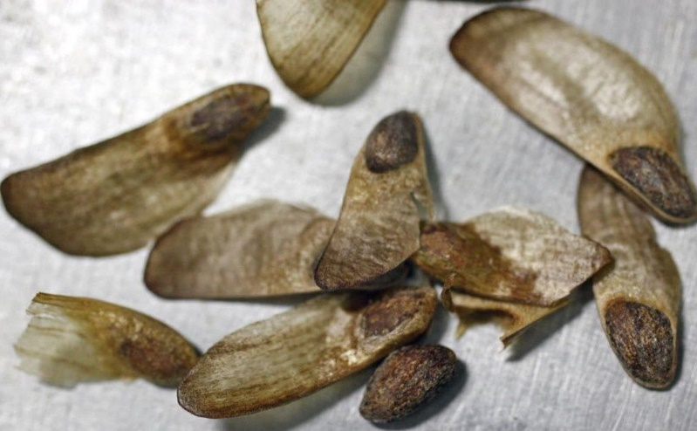
a. wings removed and classified as inert matter
b. intact seeds with or without wing are considered pure seed
c. seeds, with or without seed coat, with or without wing(s) are considered pure seed

18. You are conducting a purity on a sample of Triticum monococcum Einkhorn wheat (seeds shown below) which PSU definition should you use?
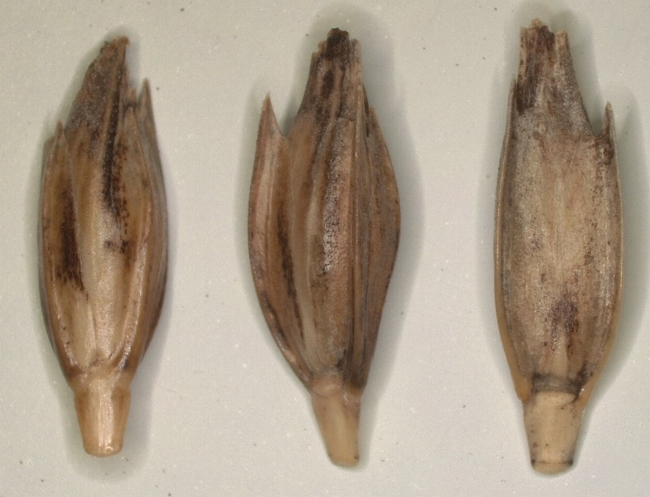
a. 12
b. 17
c. 14
d. 15

Classify the following as pure seed or inert matter:
19. The following Glycine max seeds found in a sample of Glycine max:
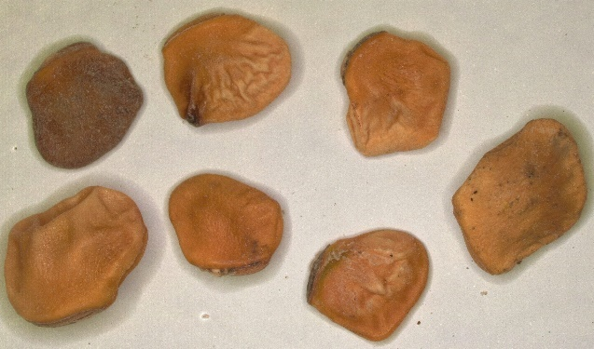
Pure seed Inert matter

20. The following Solanum lycopersicum seeds found in a sample of Solanum lycopersicum
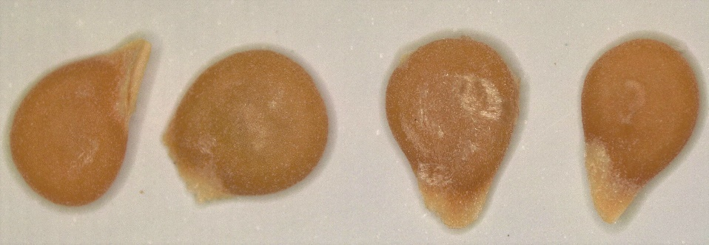
Pure seed Inert matter
21. The following Calendula officinalis seeds found in a sample of Calendula officinalis.
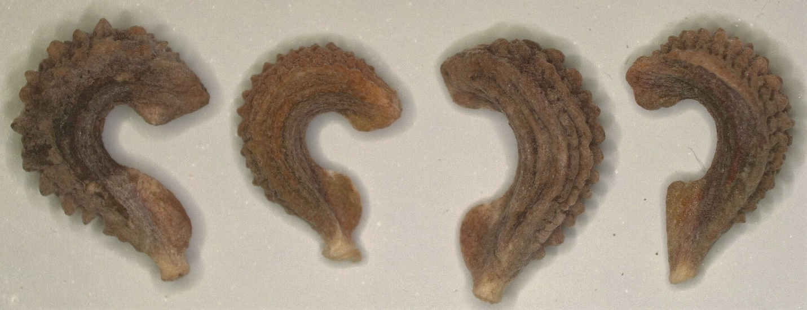
Pure seed Inert

22. The following Zea mays seed found in a sample of Zea mays.
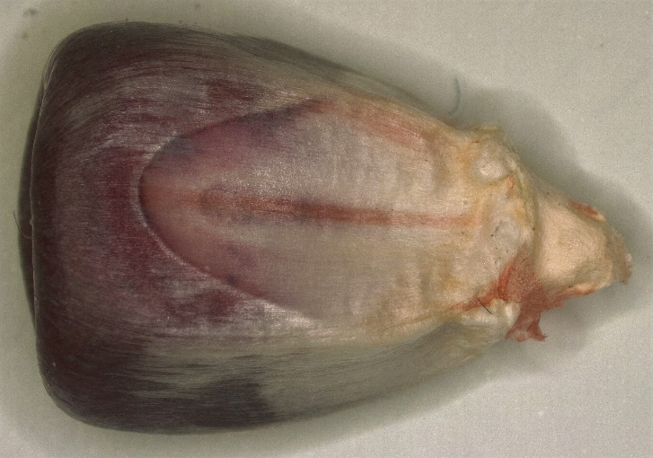
Pure seed Inert matter
23. The following Cenchrus americanus seeds found in a sample of Cenchrus americanus. (The top center seed is for reference to the average size of the seed sample.)
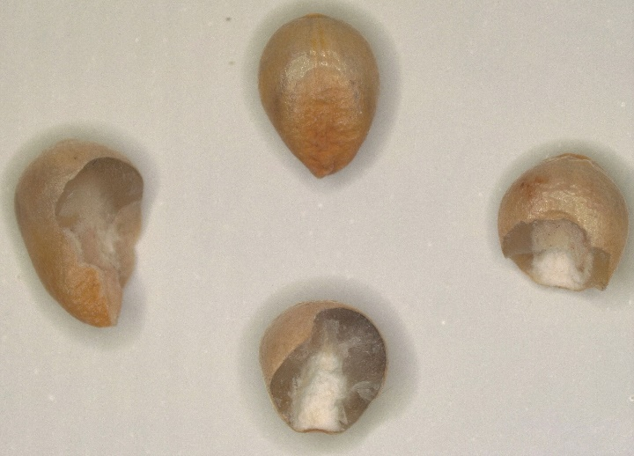
Pure seed Inert matter
24. The following Capsicum spp. seeds found in a sample of Capsicum spp.
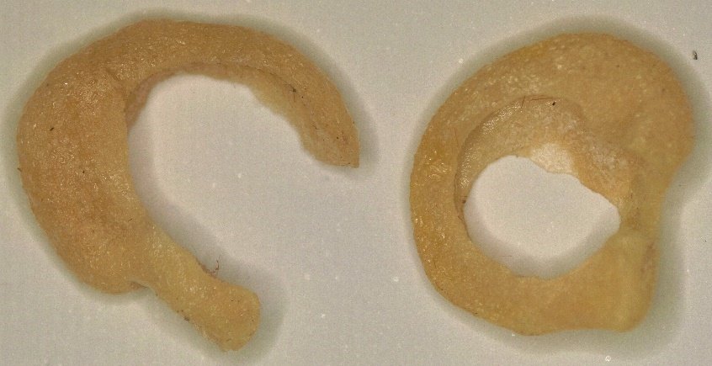
Pure seed Inert matter
25. The following Spinacia oleracea seeds found in a sample of Spinacia oleracea.
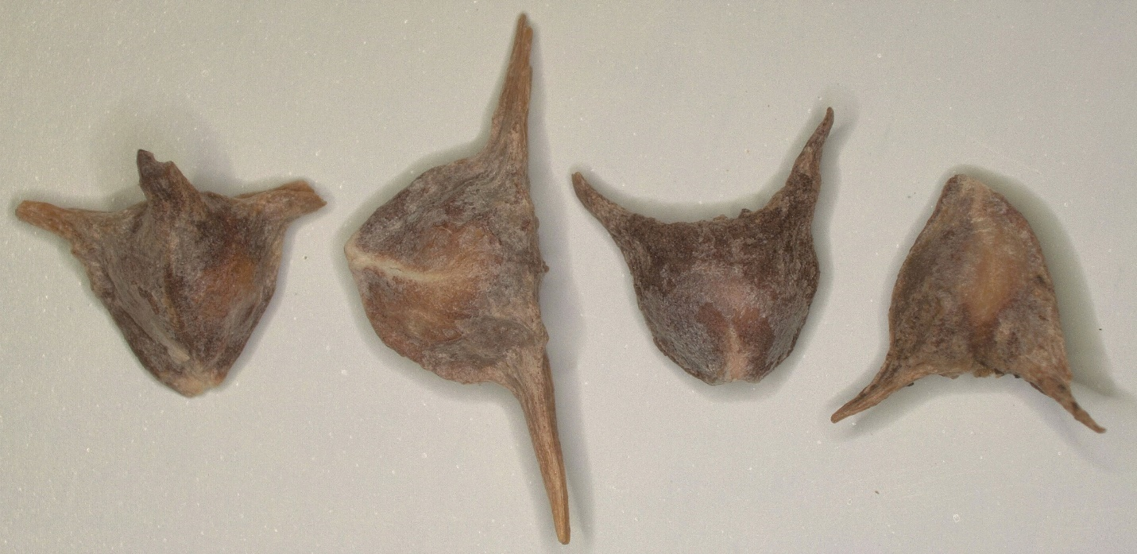
Pure seed Inert matter

26. The following Fagopyrum esculentum seeds found in a sample of Fagopyrum esculentum.
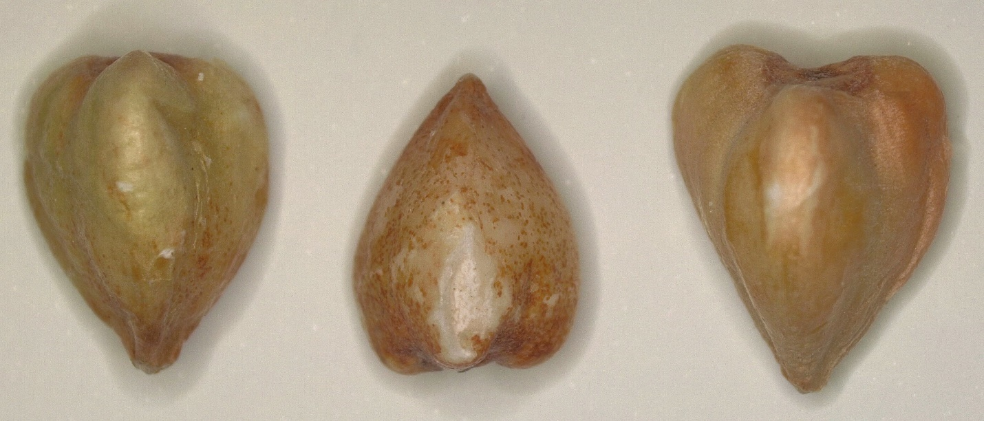
Pure seed Inert matter

27. The following Poa pratensis seeds that blew up into the top receiving pan when used at the correct gate opening setting and EAV for the general blower when found in Poa pratensis.
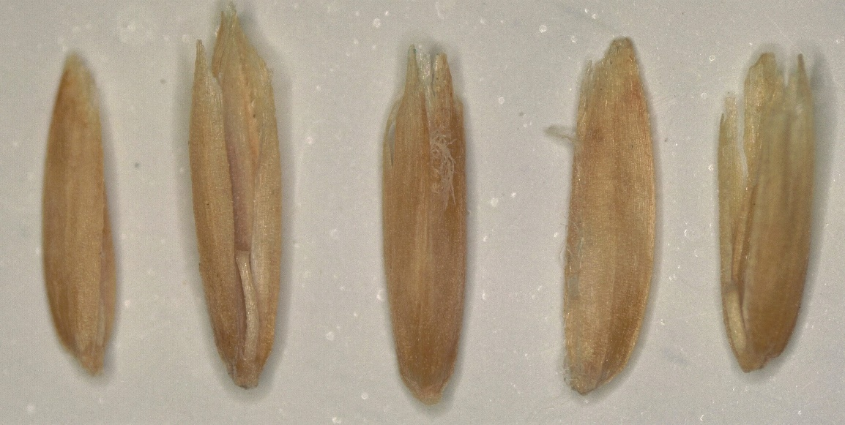
Pure seed Inert matter
28. The following Glycine max seed found in a sample of Glycine max.
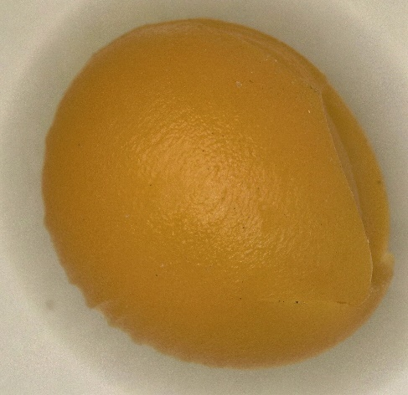
Pure seed Inert matter
29. The following Anthriscus cerefolium seeds found in a sample of Anthriscus cerefolium.
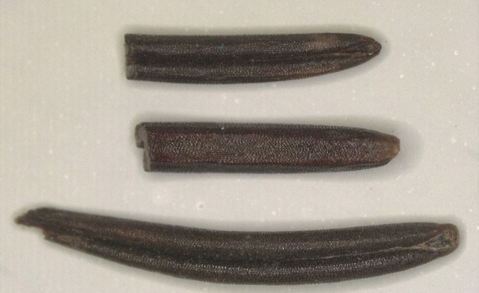
Pure seed Inert matter
30. The following Cenchrus americanus seeds found in a sample of Cenchrus americanus.
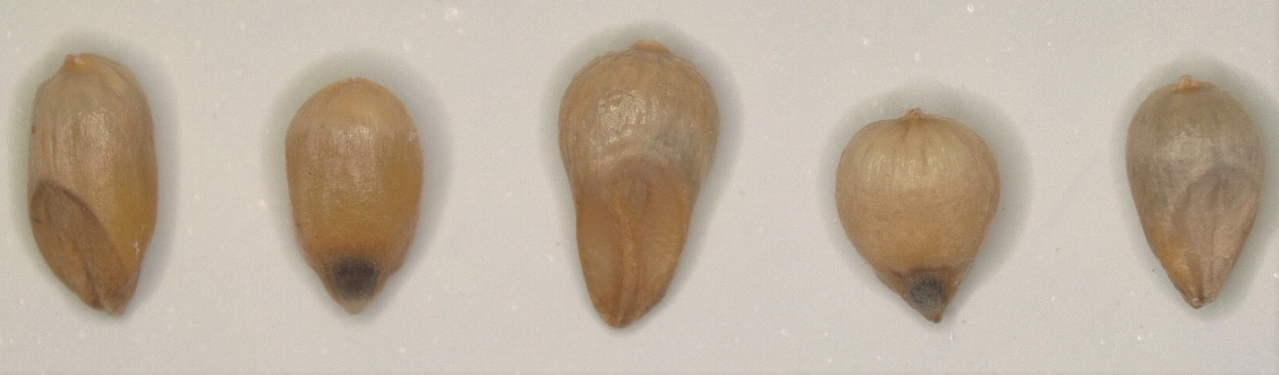
Pure seed Inert matter
31. The following Coriandrum sativum seeds when found in a sample of Coriandrum sativum.
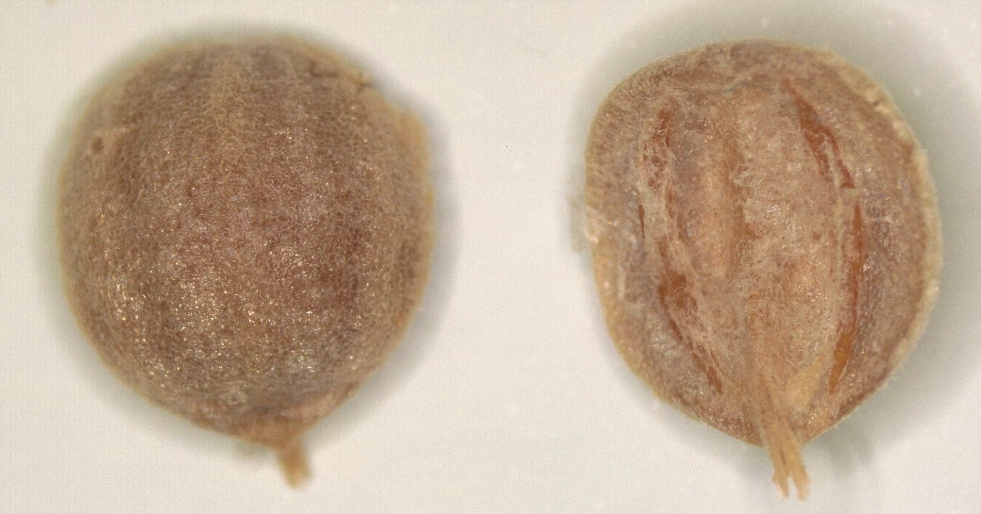
Pure seed Inert matter
32. The following Helianthus annuus seeds when found in a sample of Helianthus annuus.
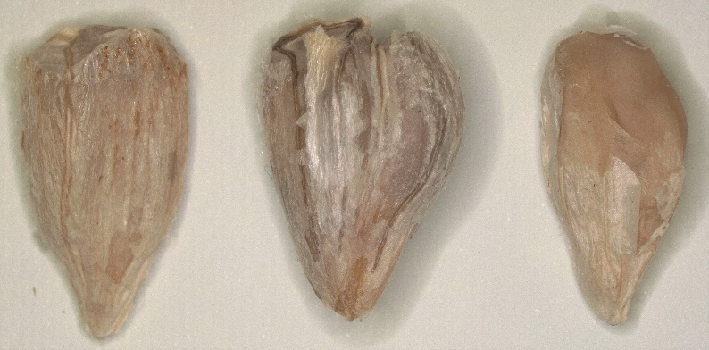
Pure seed Inert matter

33. The following Glycine max seeds when found in a sample of Glycine max.
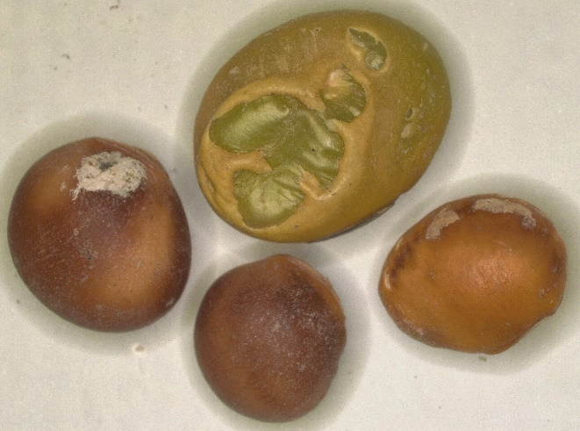
Pure seed Inert matter

34. The following Zinnia elegans seeds when found in a sample of Zinnia elegans.
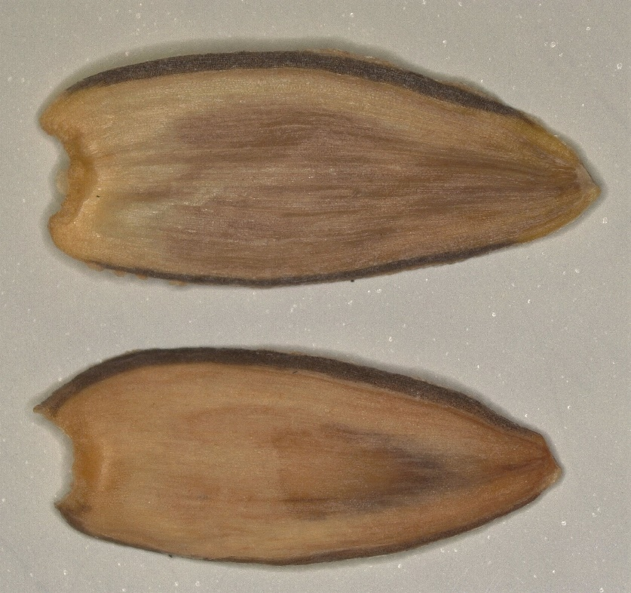
Pure seed Inert matter

35. The following Sorghum bicolor seeds when found in a sample of Sorghum bicolor.
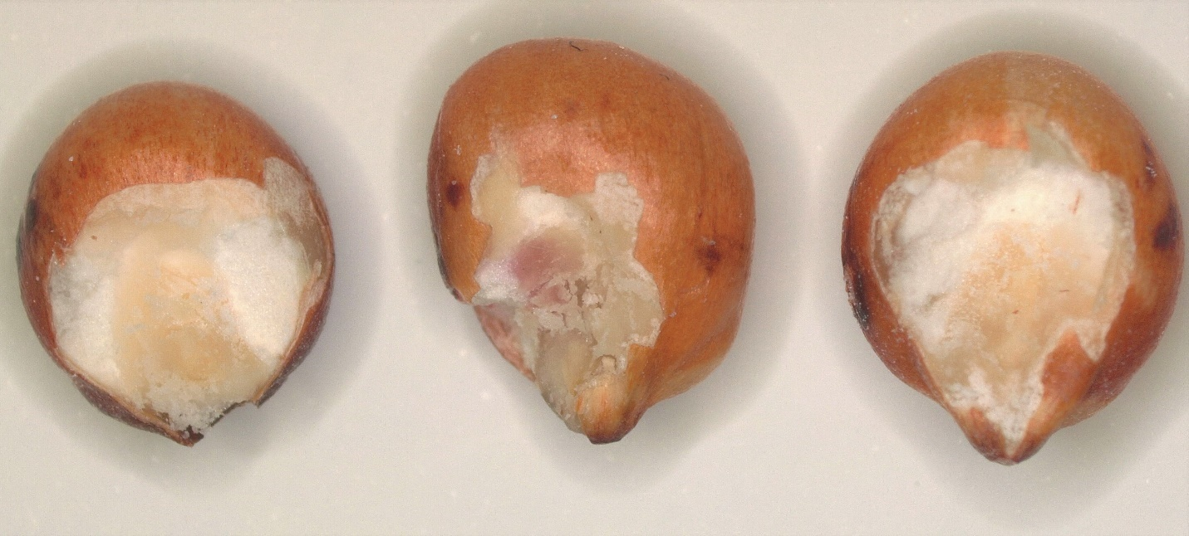
Pure seed Inert matter

36. The following Triticum aestivum when found in a sample of Triticum aestivum.
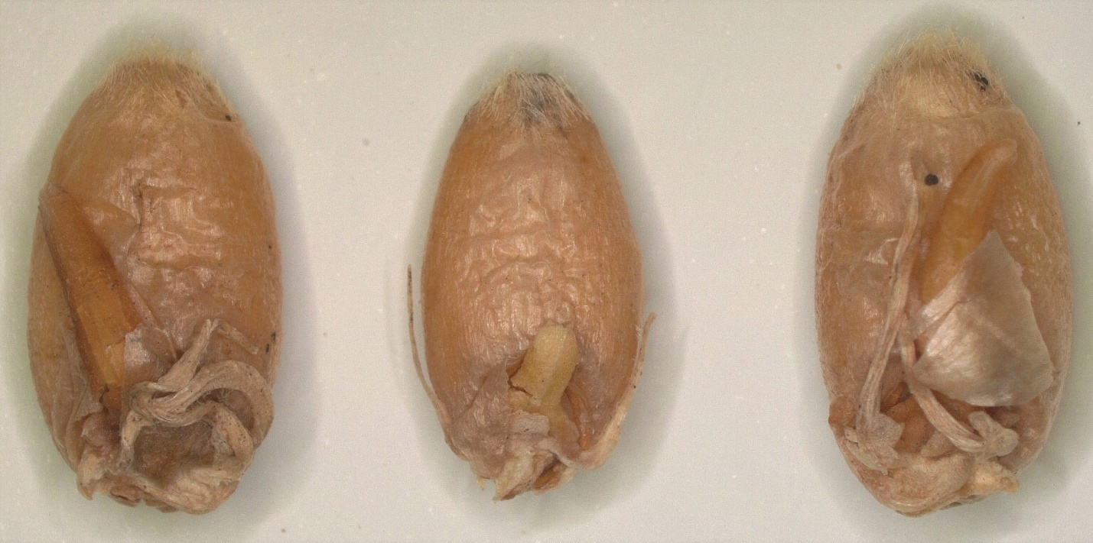
Pure seed Inert matter

37. The following Beta vulgaris L. subsp. vulgaris seeds when found in a sample of Beta vulgaris L. subsp. vulgaris.
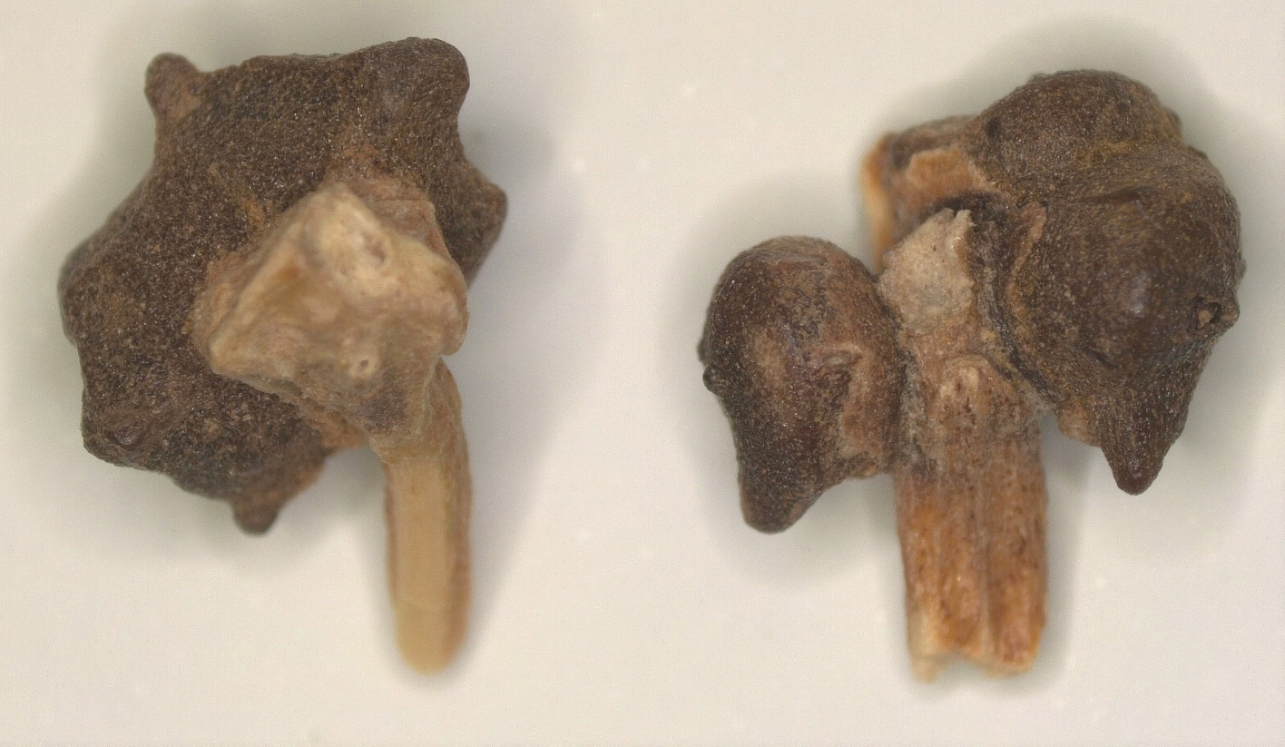
Pure seed Inert matter

38. The following Fagopyrum esculentum seeds found in a sample of Fagopyrum esculentum.
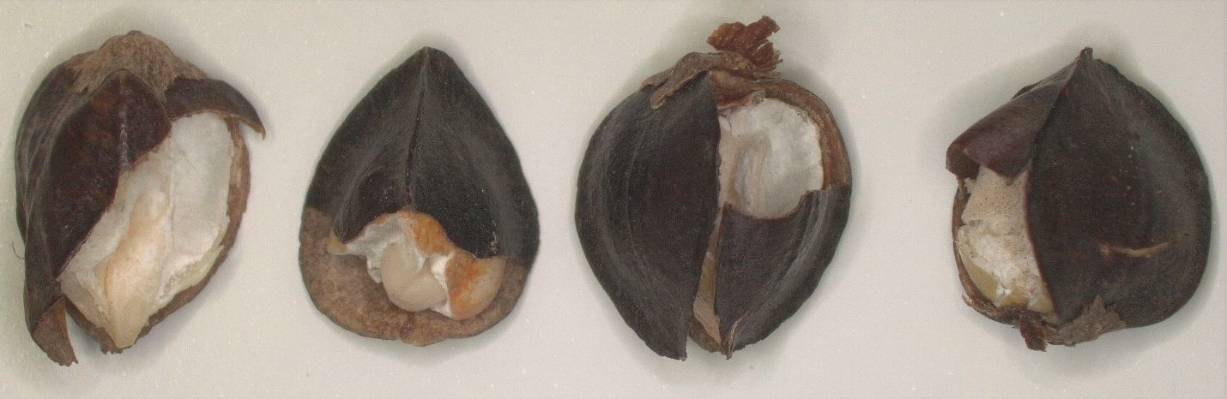
Pure seed Inert matter

39. The following Salvia officinalis seeds when found in a sample of Salvia officinalis.
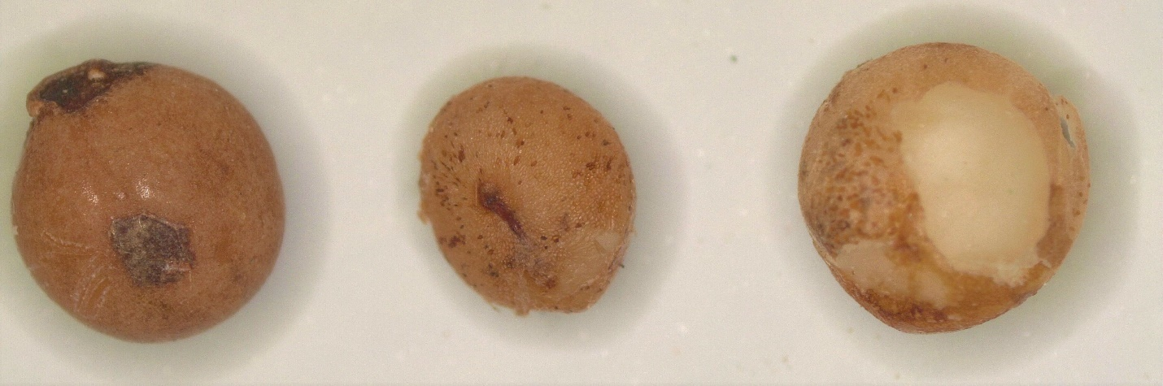
Pure seed Inert matter

40. On the following Oryza sativa seeds do the stems remain attached or are they removed and classified as inert?
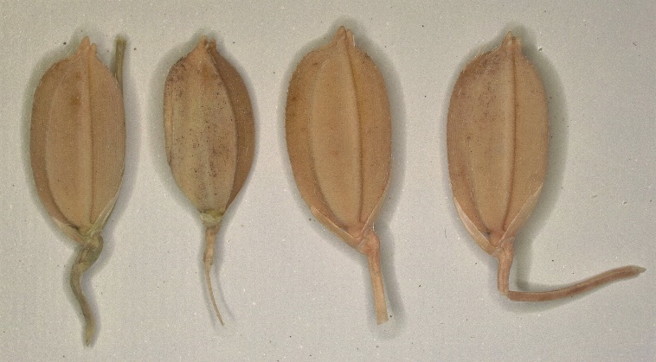
Leave attached Remove and classify as inert matter
41. Coating material found in a coated sample of Medicago sativa
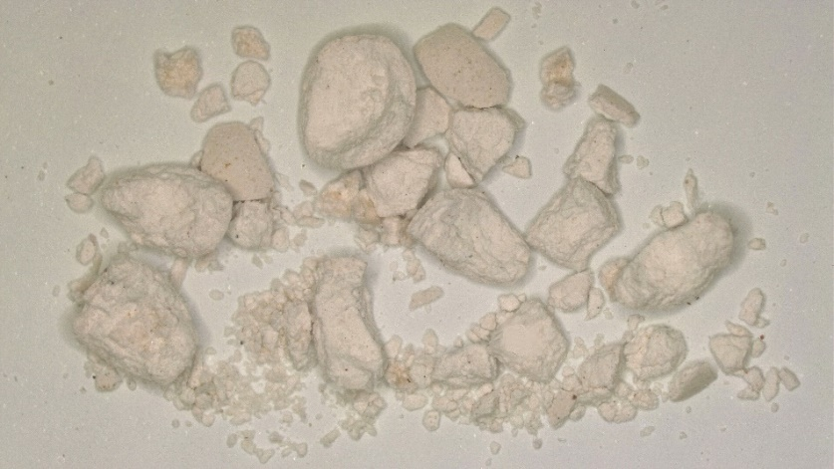
Pure seed Inert matter
42. The following Asparagus officinalis seeds when found in Asparagus officinalis.
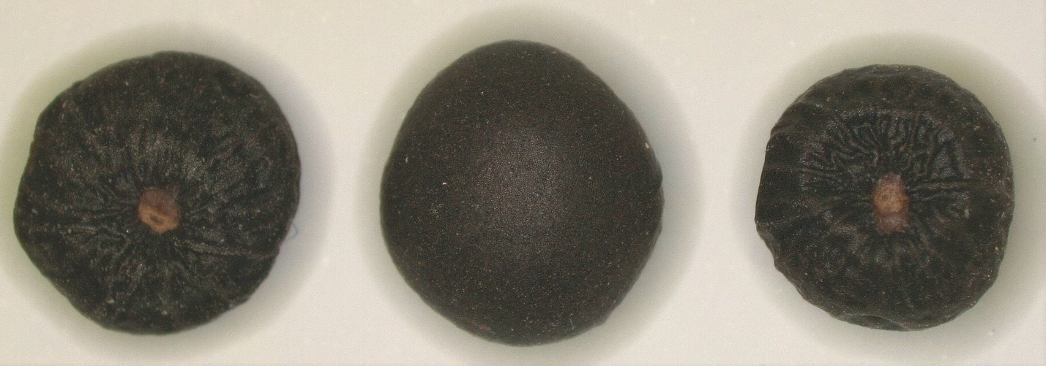
Pure seed Inert matter

43. The following Crotalaria juncea when found in Crotalaria juncea.
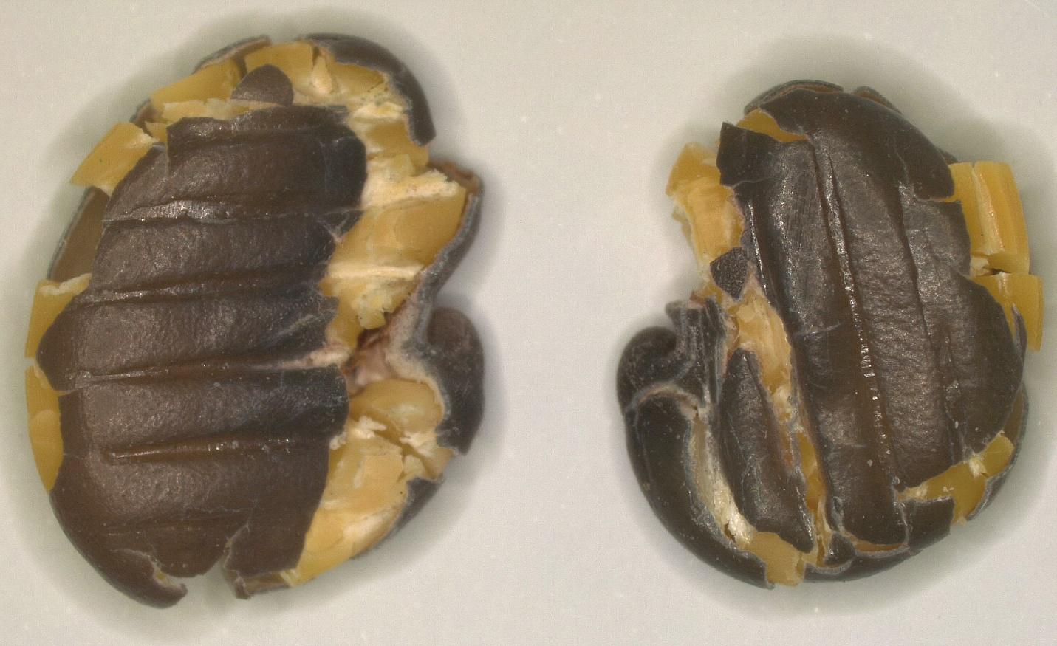
Pure seed Inert matter

44. The following Bouteloua dactyloides seeds when found in Bouteloua dactyloides.
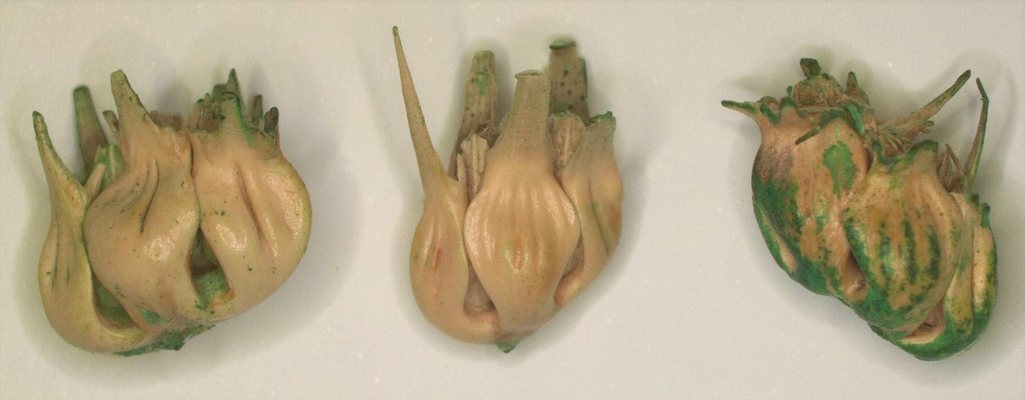
Pure seed Inert matter

45. The following Asclepias syriaca seeds when found in Asclepias syriaca.
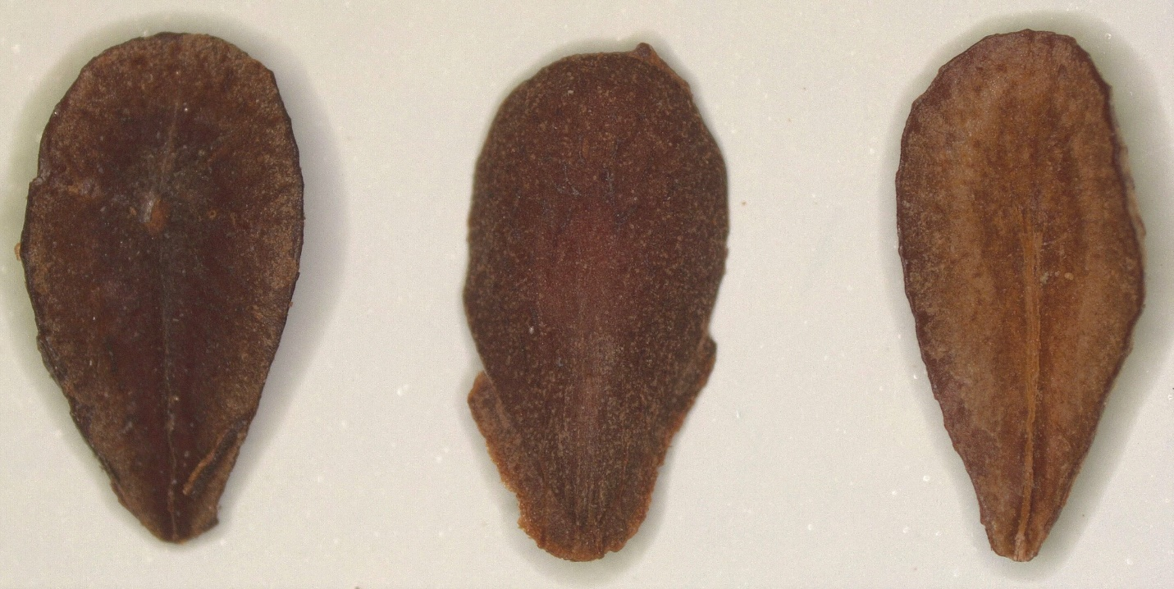
Pure seed Inert matter

46. The following Abelmoschus esculentus seeds when found in Abelmoschus esculentus.
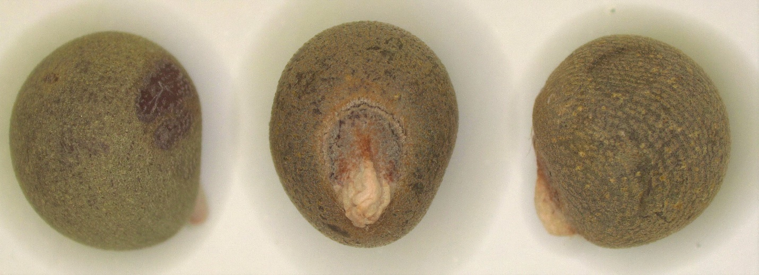
Pure seed Inert matter

47. The following Vigna unguiculata subsp. unguiculata when found in Vigna unguiculata subsp. unguiculata.
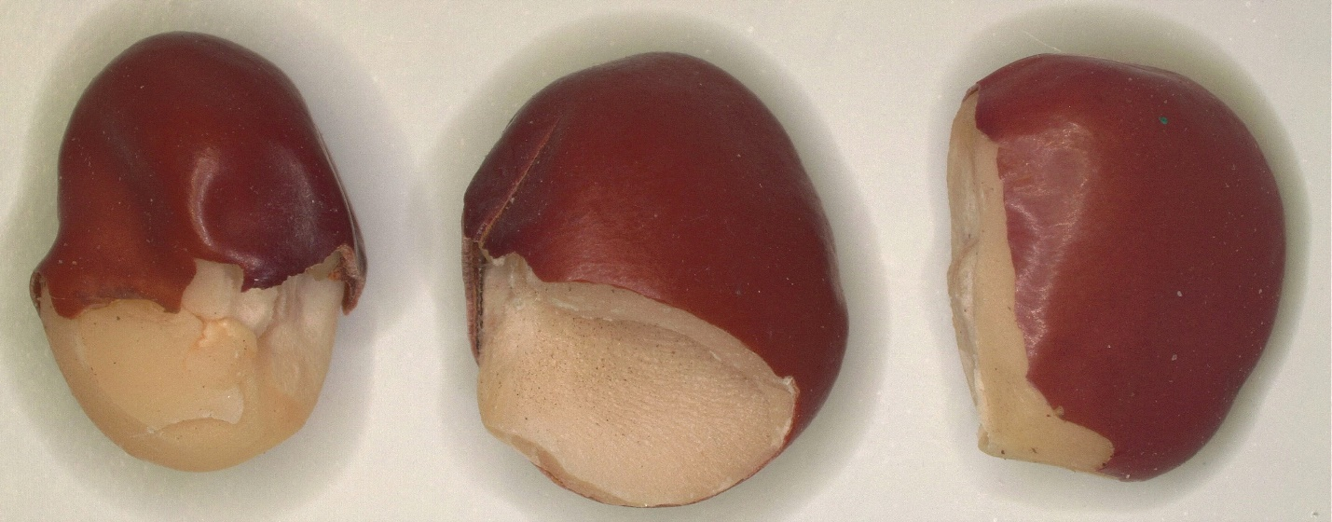
Pure seed Inert matter

48. The following Festuca arundinacea when found in Festuca arundiancea.
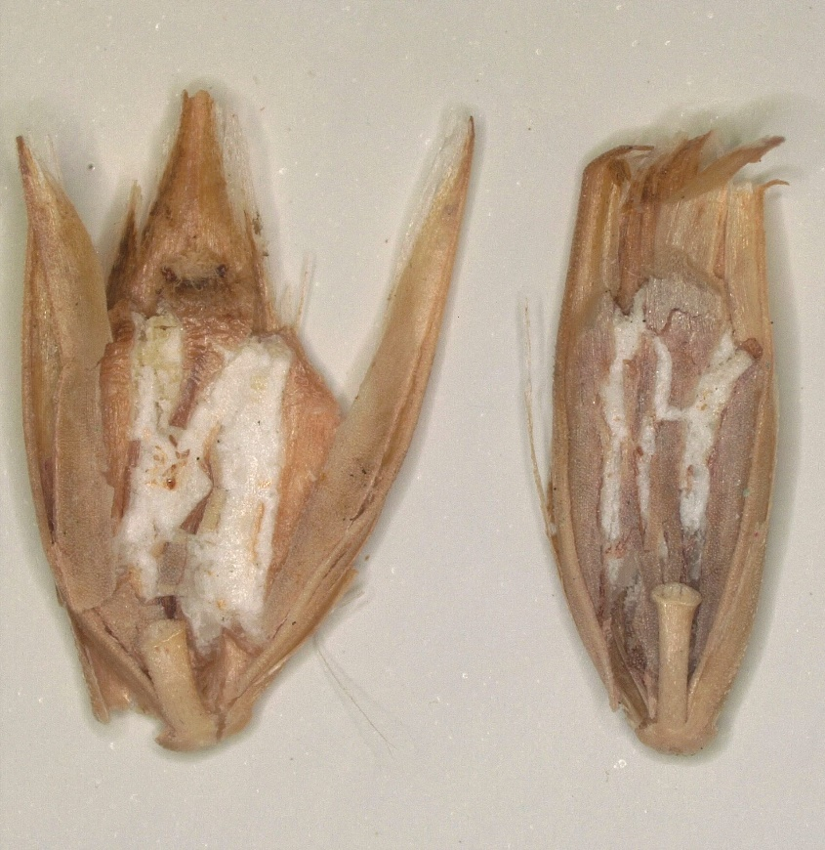
Pure seed Inert matter

49. The following Atriplex canescens when found in Atriplex canescens.
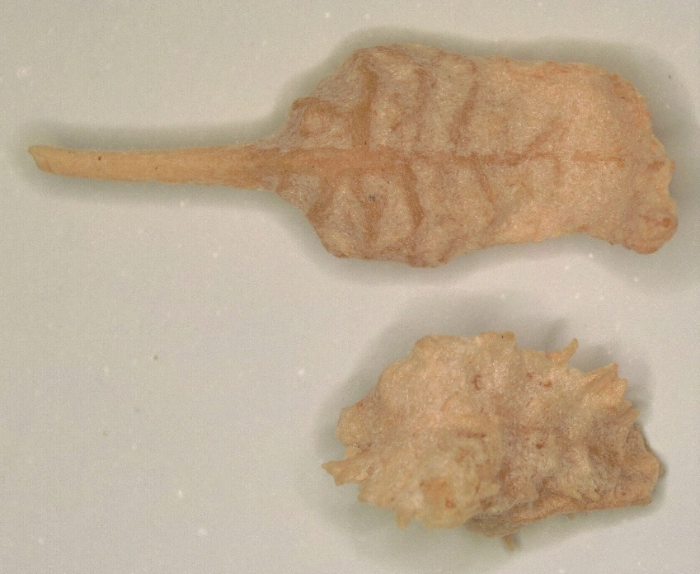
Pure seed Inert matter
50. The following Pensacola bahiagrass (Paspalum notatum) seed units in a sample of Pensacola bahiagrass that remained in the bottom sample cup after the sample was blown at the correct gate setting and EAV for the general blower.
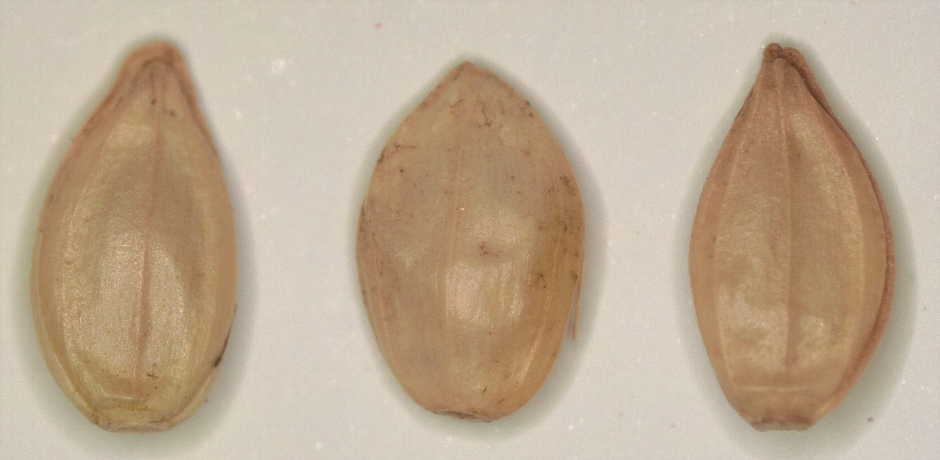
Pure seed Inert matter

51. The following Tetragonia tetragonoides seeds that were found in Tetragonia tetragonoides
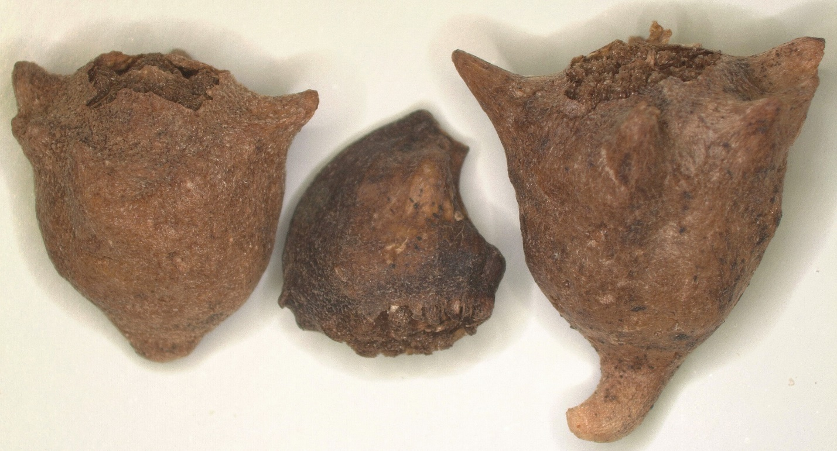
Pure seed Inert matter
52. The following Dactylis glomerata seed units that were blown into the top receiving pan of the general blower when used at the correct gate opening setting and EAV of the general blower when found in Dactylis glomerata.
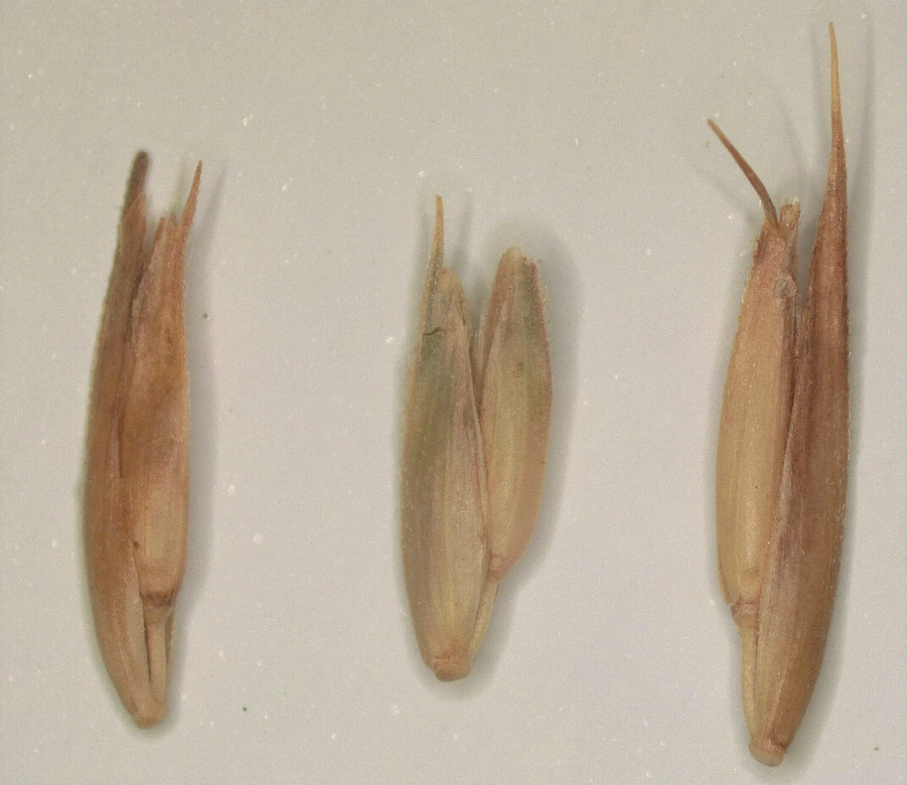
Pure seed Inert matter
53. The following Bromus inermis subsp. inermis seeds when found in Bromus inermis subsp. inermis.
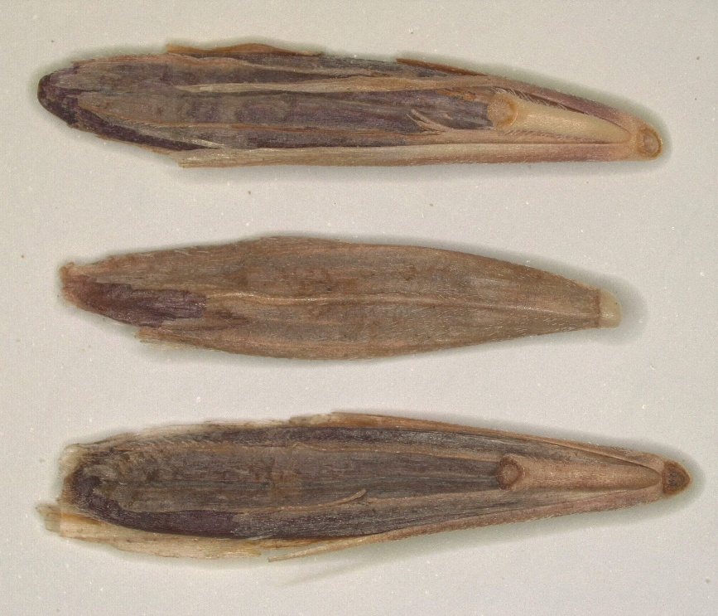
Pure seed Inert matter

