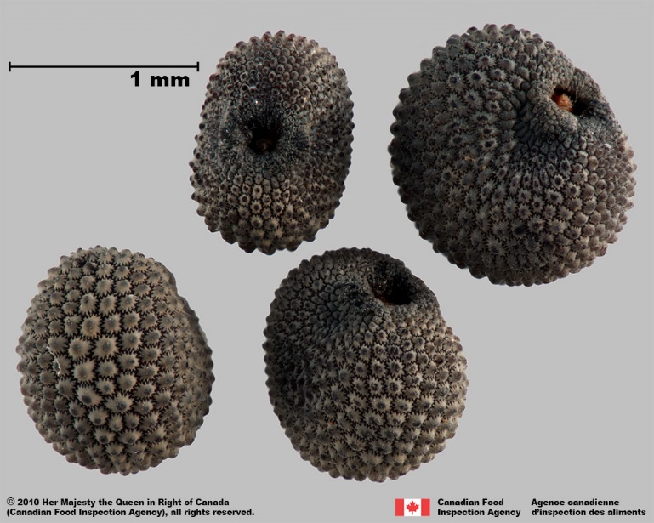 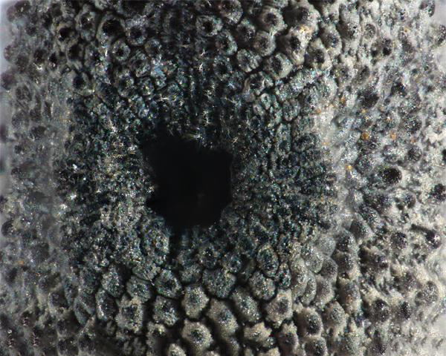

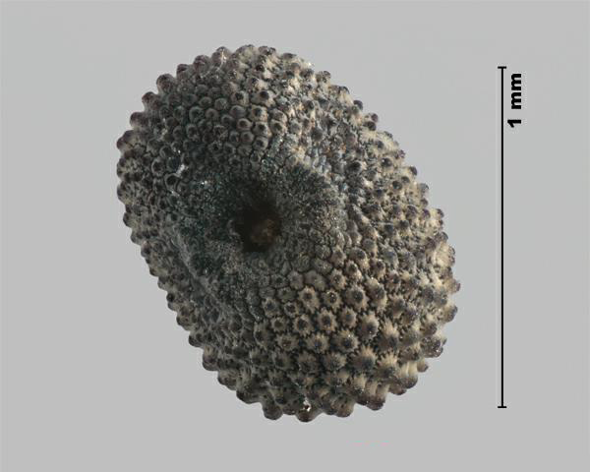

1.

When found in a sample of alfalfa it is:

2. a. weed seed

b. crop seed

c. noxious weed

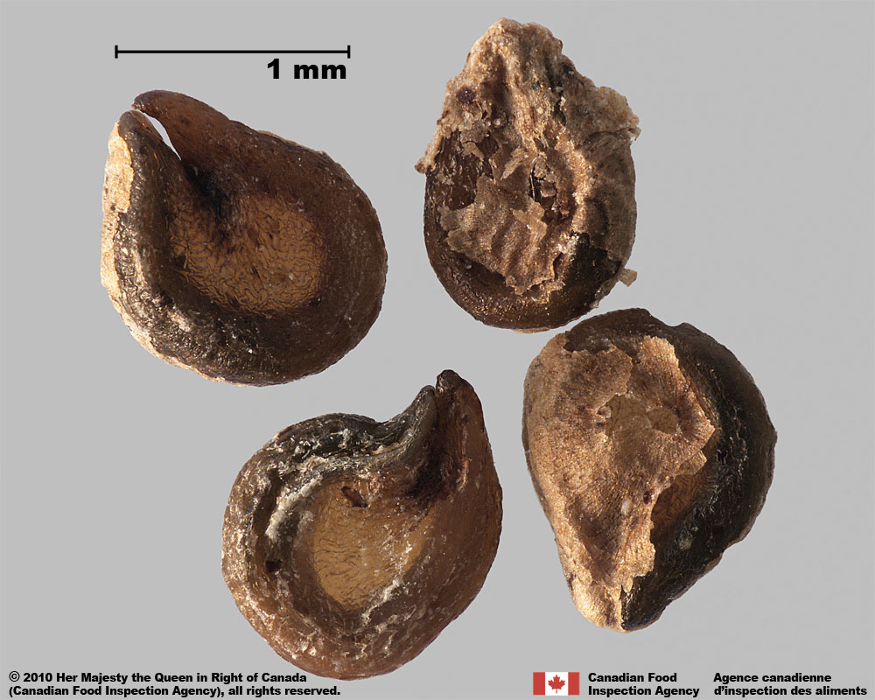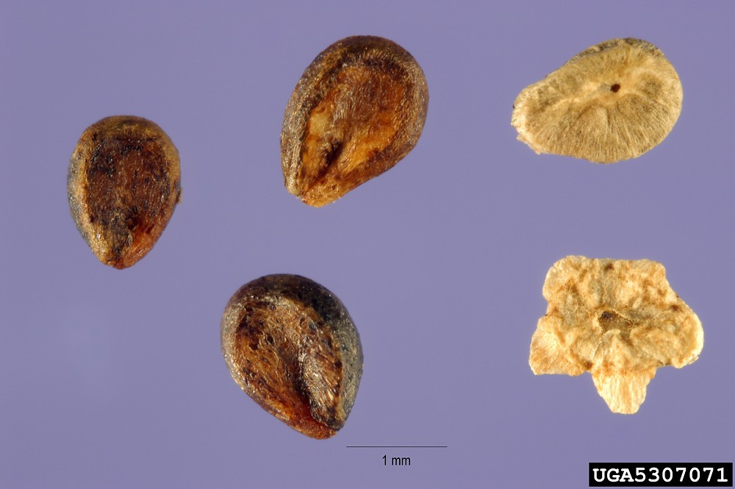

3.

When found in a sample of proso millet it is:

4. a. weed seed

b. crop seed

c. noxious weed

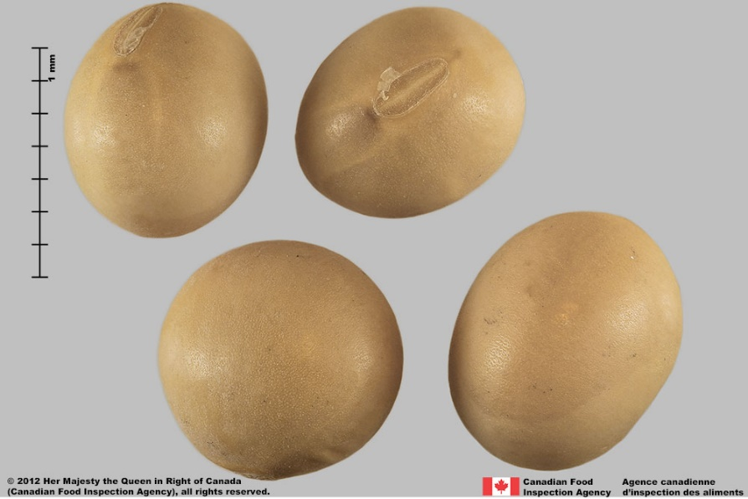 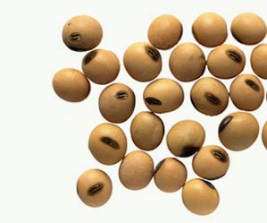

5.

When found in a sample of field peas it is:

6. a. weed seed

b. crop seed

c. noxious weed

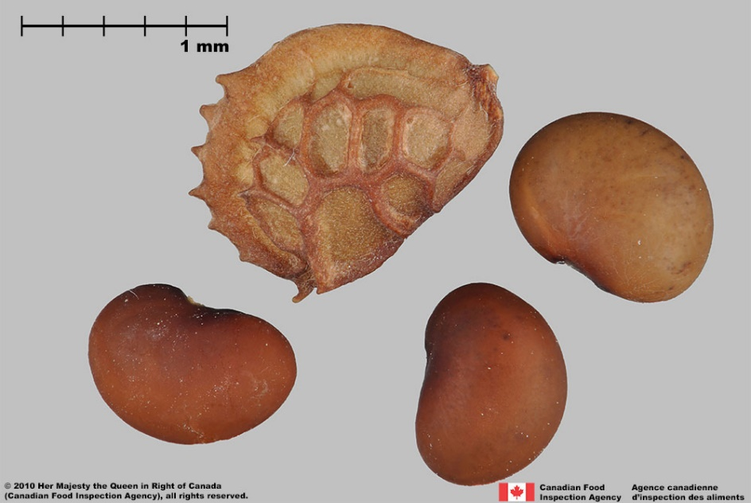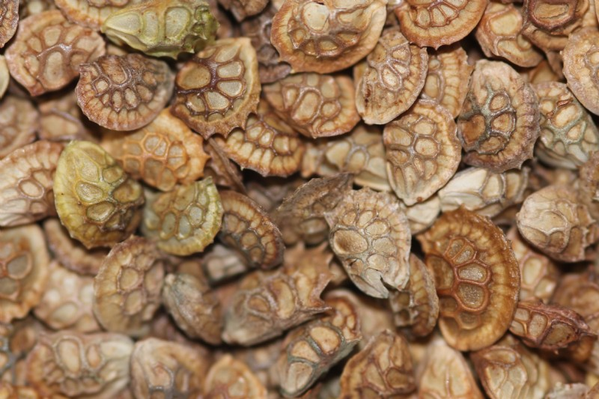

7.

When this seed is found in a sample of alfalfa it is:

8. a. weed seed

b. crop seed

c. noxious weed

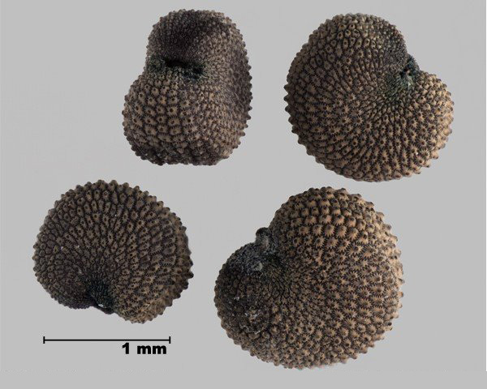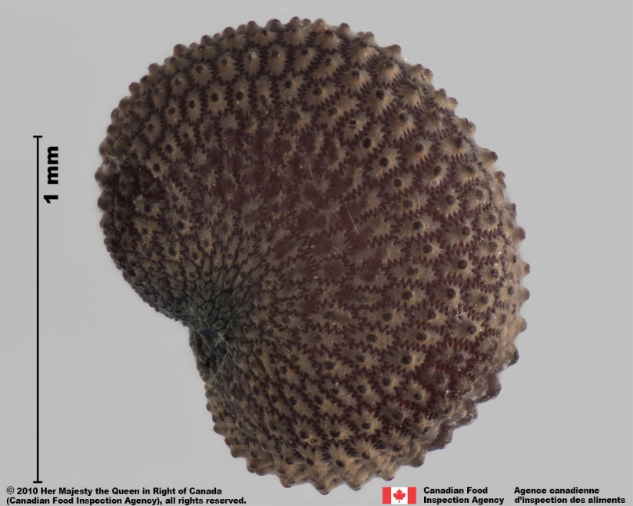

9.

When this seed is found in a sample of red clover it is:

10. a. weed seed

b. crop seed

c. noxious weed

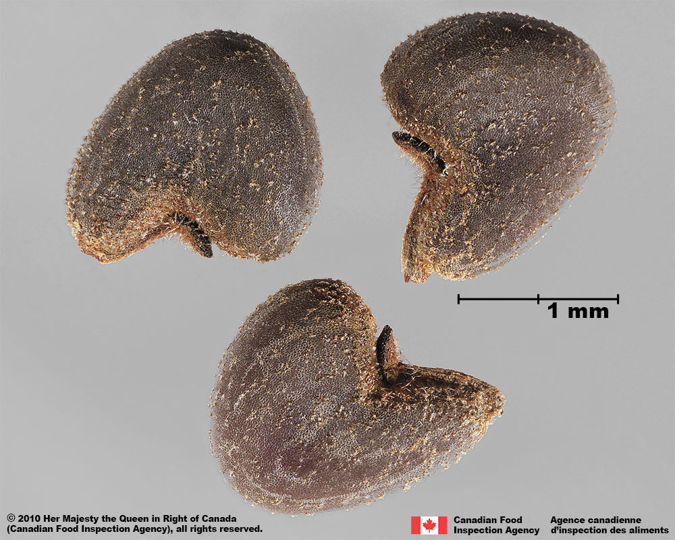

11.

When this seed is found in a sample of corn it is:

12. a. weed seed

b. crop seed

c. noxious weed

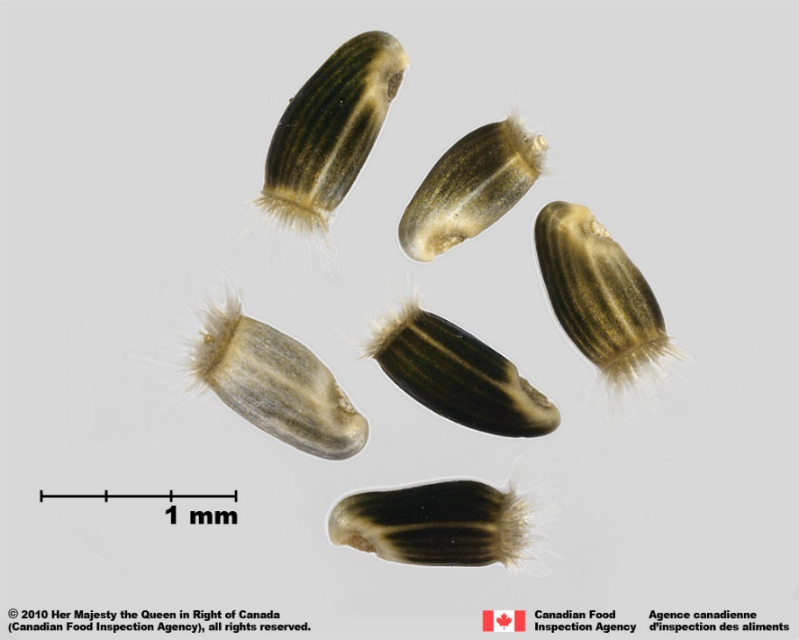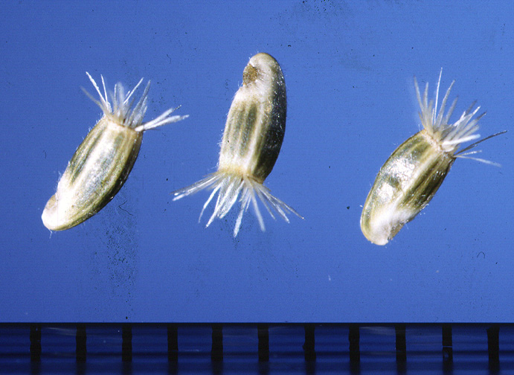

13.

When this seed is found in a sample of wheat it is:

14. a. weed seed

b. crop seed

c. noxious weed

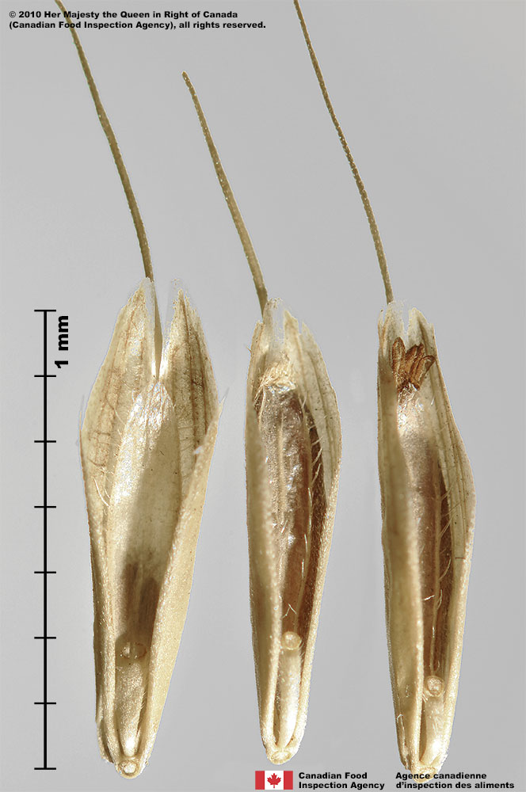 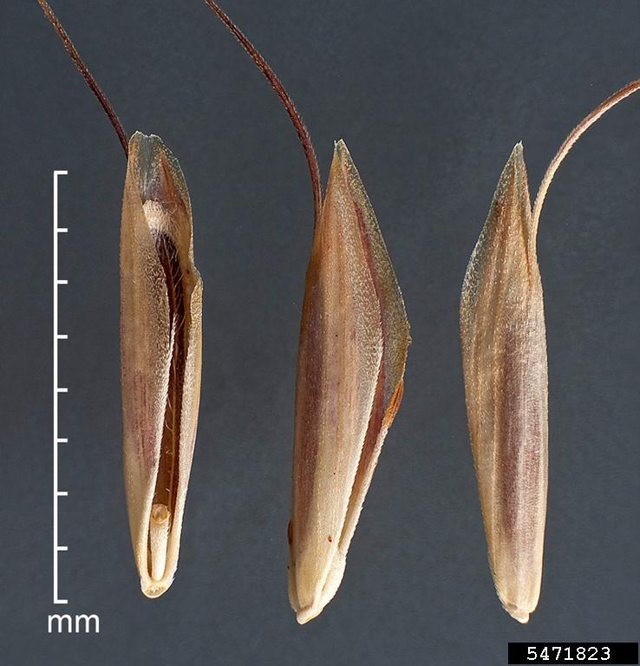

15.

When this seed is found in a sample of a grass mixture composes of tall fescue, ryegrass, brome, and orchardgrass it is:

16. a. weed seed

b. crop seed

c. noxious weed

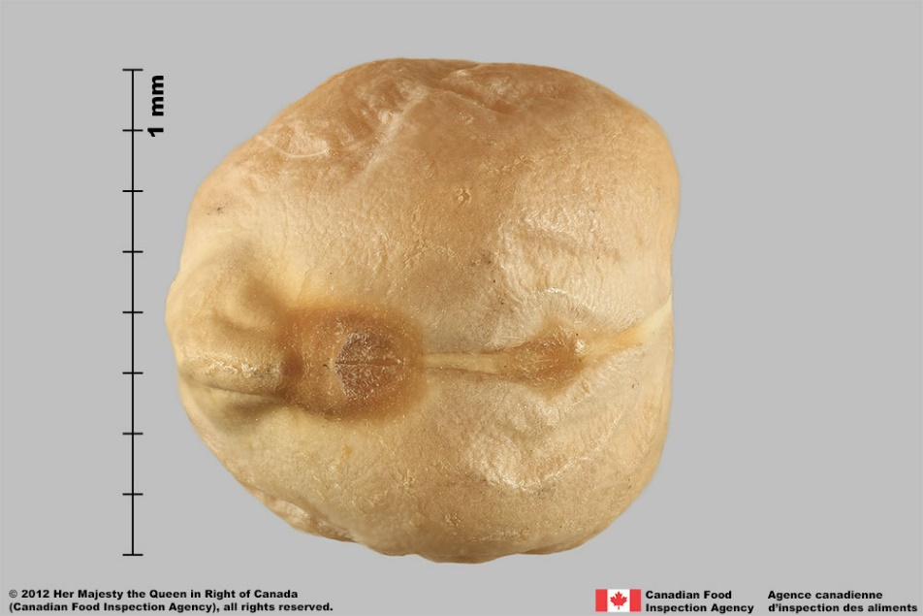 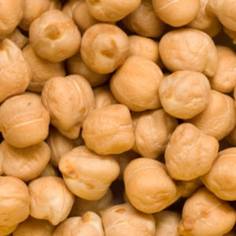

17.

When this seed is found in a sample of field beans it is:

18. a. weed seed

b. crop seed

c. noxious weed

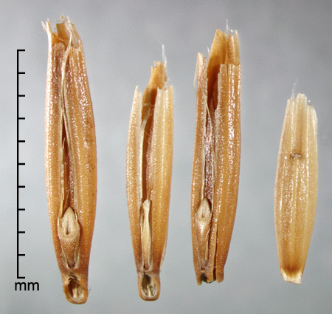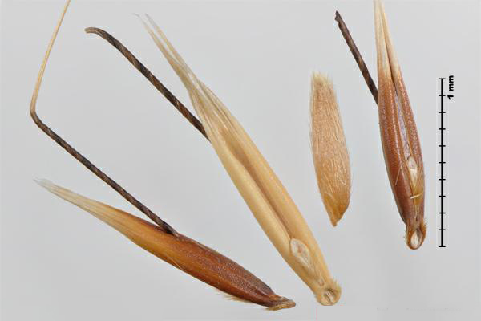

19.

When this seed is found in a sample of oats it is:

20. a. weed seed

b. crop seed

c. noxious weed

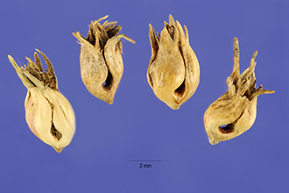 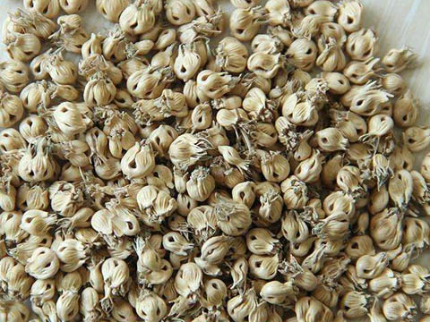

21.

When found in a sample of Kentucky bluegrass it is:

22. a. weed seed

b. crop seed

c. noxious weed

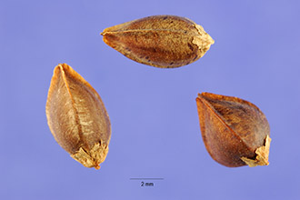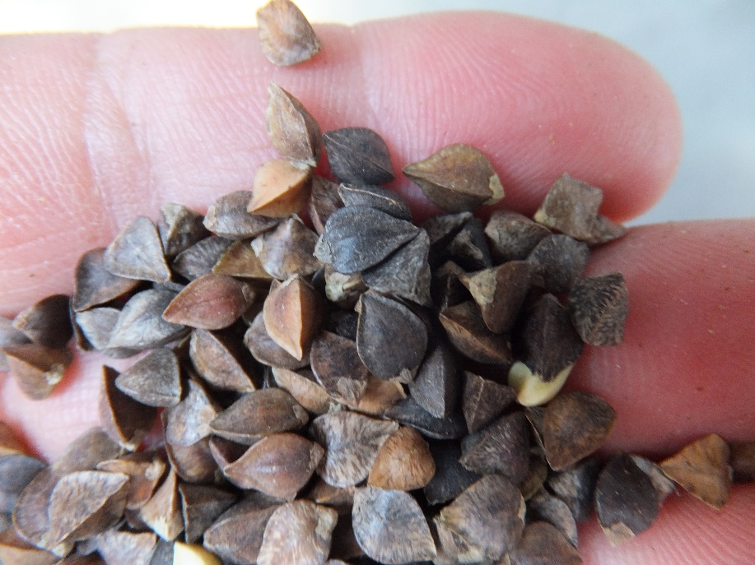

23.

When this seed is found in a sample of oats is:

24. a. weed seed

b. crop seed

c. noxious weed

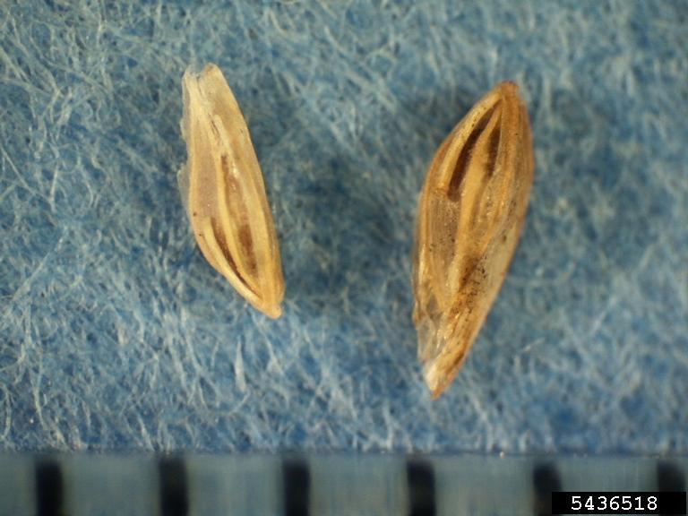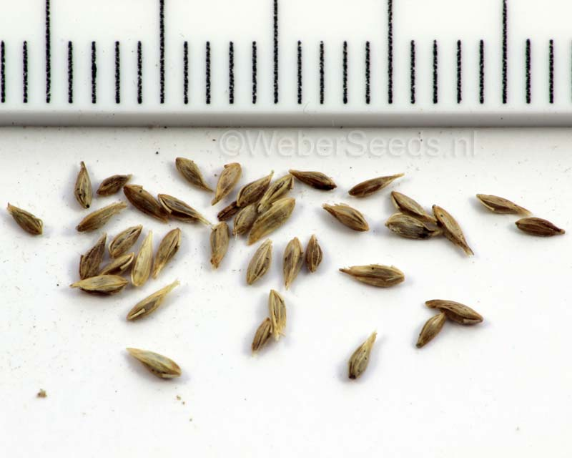

25.

When this seed is found in a sample of Kentucky bluegrass it is:

26. a. weed seed

b. crop seed

c. noxious weed

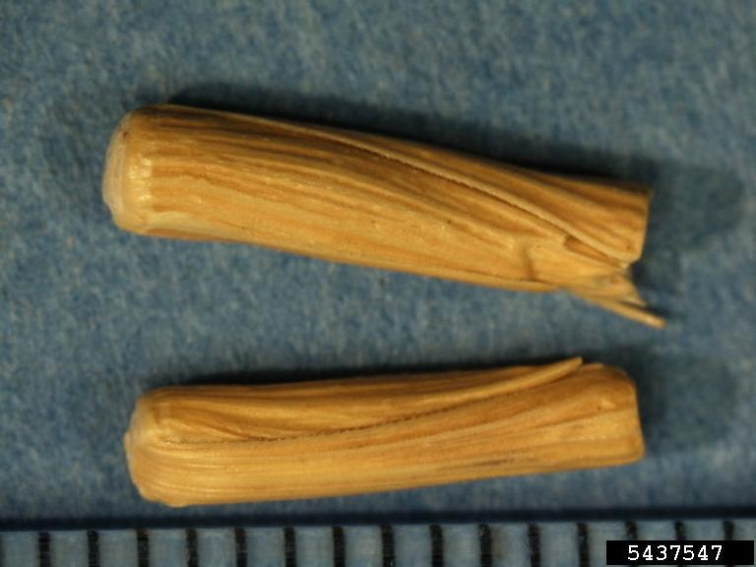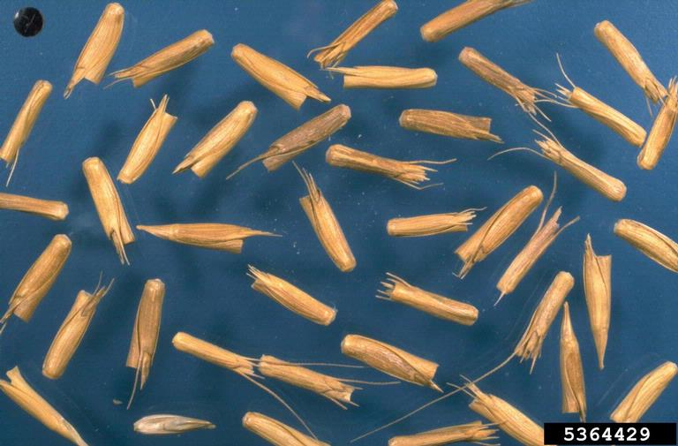

27.

When this seed found in a sample of intermediate wheatgrass is:

28. a. weed seed

b. crop seed

c. noxious weed

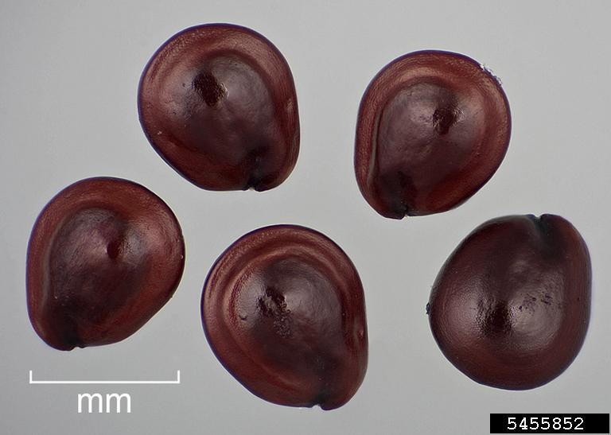 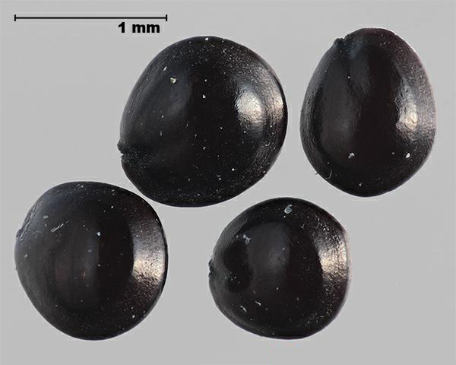.

29.

When this seed is found in a sample of sunflower is:

30. a. weed seed

b. crop seed

c. noxious weed

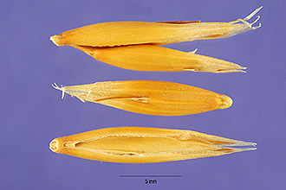

31. found in a sample of Indian rice grass is:

32. a. weed seed

b. crop seed

c. noxious weed

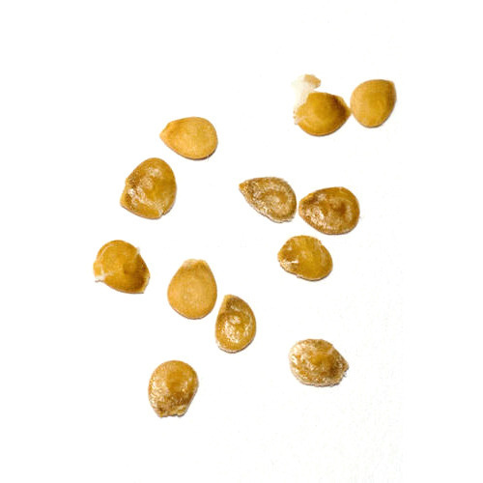 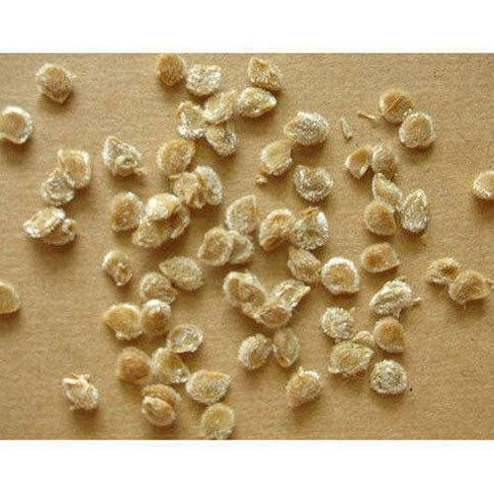

33. found in a sample of pepper is:

34. a. weed seed

b. crop seed

c. noxious weed

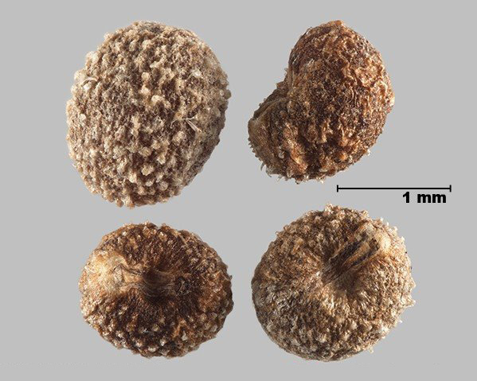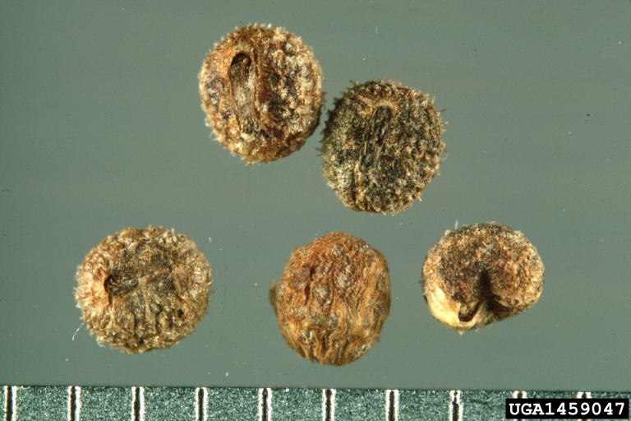

35. found in a sample of pepper is:

36. a. weed seed

b. crop seed

c. noxious weed

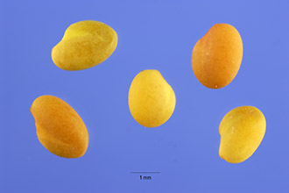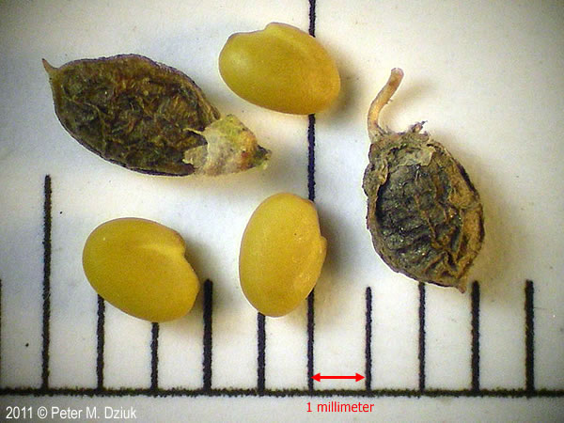

37. found in a sample of alfalfa is:

38. a. weed seed

b. crop seed

c. noxious weed