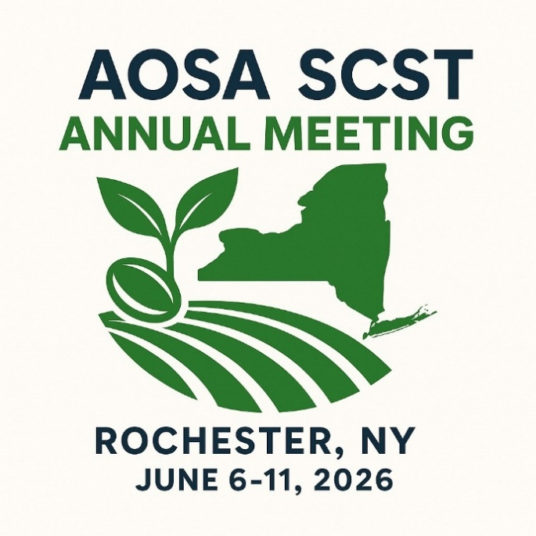

2026 AOSA/SCST Annual Meeting
DRAFT AGENDA
All times listed are in EASTERN TIME
Times/dates/room assignments subject to change

**Some schedule items may change following the merger vote; we will continue to update the agenda and keep participants posted**

VIRTUAL MEETINGS (Pre-annual meeting)
Vigor Committee: May 26th; 3pm CST
Germination Committee: date/time TBD

SATURDAY, JUNE 6
8am-4pm: AOSA BOD Meeting (Closed)
Room:

8am-4pm: SCST BOD Meeting (Closed)
Room:

SUNDAY, JUNE 7
7:30am-5pm: Registration
Room:

7am-8am: Breakfast
Room:

8am-4pm: AOSA/SCST Joint BOD Meeting (Closed)
Room: Corinthian

8am-Noon: RGT Exam
Room:

8am-12pm: Workshop: Statistical Analysis of Method Comparison for Germ Tests Incorporating AI

Workshop overview: To ensure an understanding of a statistical analysis of method comparison for germ tests, data visualization, and the incorporation of AI tools into research and presentations.
Room:

Noon-1pm: Lunch for BOD and Workshops
Room:

Noon-5pm: Exhibitor Set-Up

**To be confirmed following merger vote:
1pm--5pm: Committee Chairs Meeting with AOSA SCST BODs
Room: Corinthian

MONDAY, JUNE 8
7am-8am: Registration

7:30am: Meeting Orientation for Newcomers
Room: Corinthian

8am-10am: Opening Session Breakfast
Room: Ballroom II

10am-Noon: Genetic Technology Committee/Cultivar Purity Committee
Room: Ballroom I

10:30am-11:30am: Flower Seed Committee
Room: Ballroom III

10:30am-11:30am: Lab Standards and Documentation
Room: River

12:00pm-1:00pm: Lunch

1pm-2pm: Handbook Committee/ Communication and Publications Committee
Room: Ballroom I

1pm-2pm: Affiliates/Liaison Meeting (Closed)
Room: Corinthian

1pm-2pm: RGT Board of Examiners (Closed)
Room: River

2pm-4pm: Teaching & Training Committee; Continuing Education Committee
Room: Ballroom I

2pm-3pm: Conservation, Reclamation, Tree & Shrub Committee
Room: Ballroom III

2:30pm-3:00pm: Afternoon Break
Room: Pre-Assembly West

3:00pm-4:00pm: Advanced Technology Committee
Room: Ballroom III

4:00pm-5:00pm: Purity Committee
Room: Ballroom I

5pm-7pm: Trade Show Mixer & Seed Issues Forum/Poster Session Reception
Room: Pre-function West

TUESDAY, JUNE 9
6:30am-7:30am: Bean Buddy Walk

7am-8:30am: Breakfast
Room: Ballroom II

7:30am-11am: Registration
Room:

8am-11am: Trade Show
Room:

8am-9am: Research Committee
Room: Ballroom I

8am-9am: Regulatory Meeting
Room: Ballroom I

9am-10am: AOSA/SCST PT Committee
Room: Ballroom I

10am-11am: TZ Committee
Room: Ballroom I

11:15am: Depart for Tour: Niagara Falls
**Tour to return to hotel at 5pm; dinner on your own

WEDNESDAY, JUNE 10
7am-8am: Breakfast
Room: Ballroom II

7:30am-5pm: Registration
Room:

8am-5pm: Trade Show
Room:

8am-9am: Open Rules Update
Room: Ballroom I

9:00am-9:15am: Morning Break

9:15am-11:00am: Referee Presentations/Referee Committee
Room: Ballroom I

11:00am-11:30am: Referee Buzz Session
Room: Ballroom I

11:30am-12:30pm: LUNCH
Room: Ballroom II

12:30pm-1:45pm: Research Paper Session
Room: Ballroom I

1:45pm-2pm: Afternoon Break
Room:

2pm-5pm: Long Range Planning
Room: Ballroom I

5pm-6pm: STRF Silent Auction
Room: Ballroom II
5:45pm: Group Photos

6pm-8pm: Awards Banquet/STRF Silent Auction
Room: Ballroom II

THURSDAY, JUNE 11
6:30am-7:30am: Breakfast
Room: Ballroom II

8am-Noon: Exhibitor Tear Down

**Times and items below to be confirmed following merger vote
7:30am-9am: Joint Business Meeting and Rules Voting Session
Room: Ballroom I

9:15am-10:45am: SCST Business Meeting
Room: Ballroom I

10:45am-12:15pm: AOSA Business Meeting
Room: Ballroom I

Meeting ENDS: Noon

